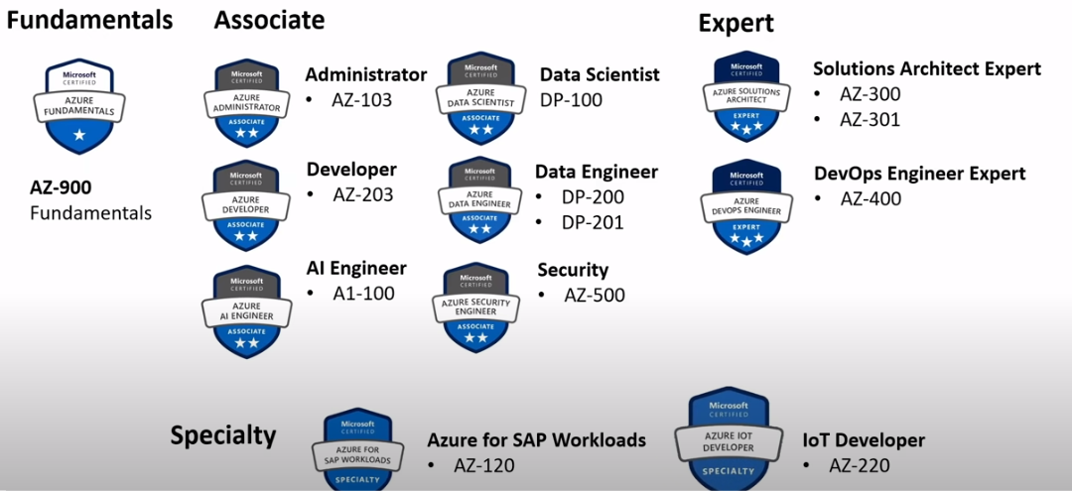

Exams code may vary from what are displayed above!!!

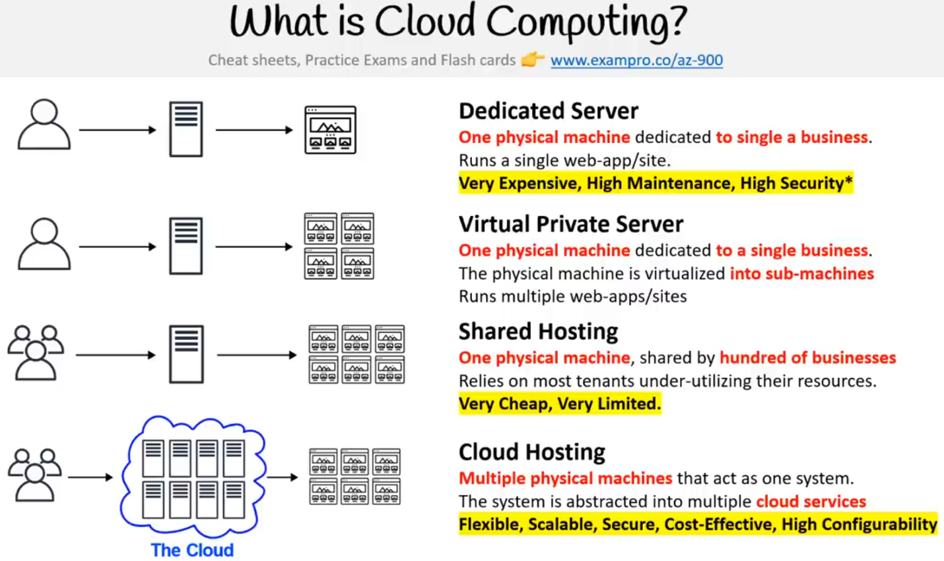

COMMON CLOUD SERVICES

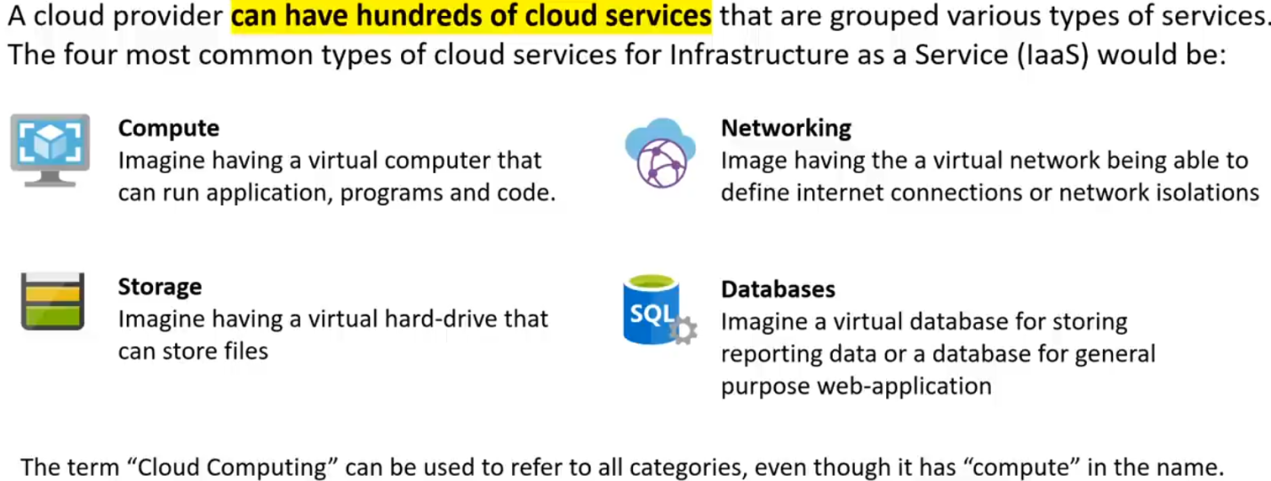

**BENEFITS OF CLOUD COMPUTING**

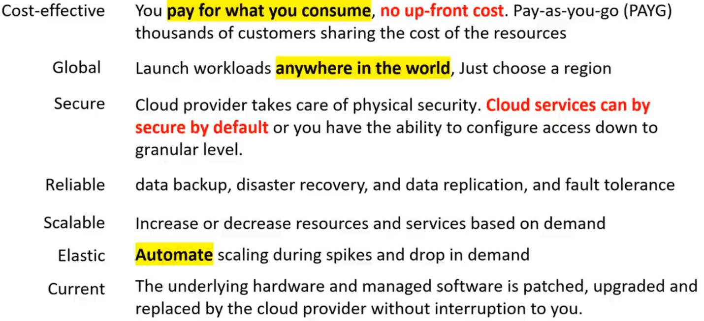

**TYPES OF CLOUD COMPUTING**

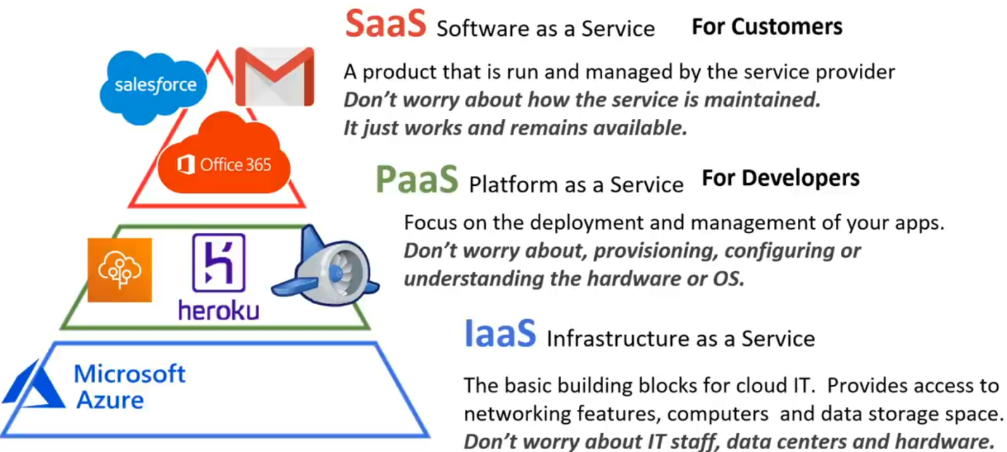

**TYPES OF CLOUD COMPUTING RESPONSIBILITIES**

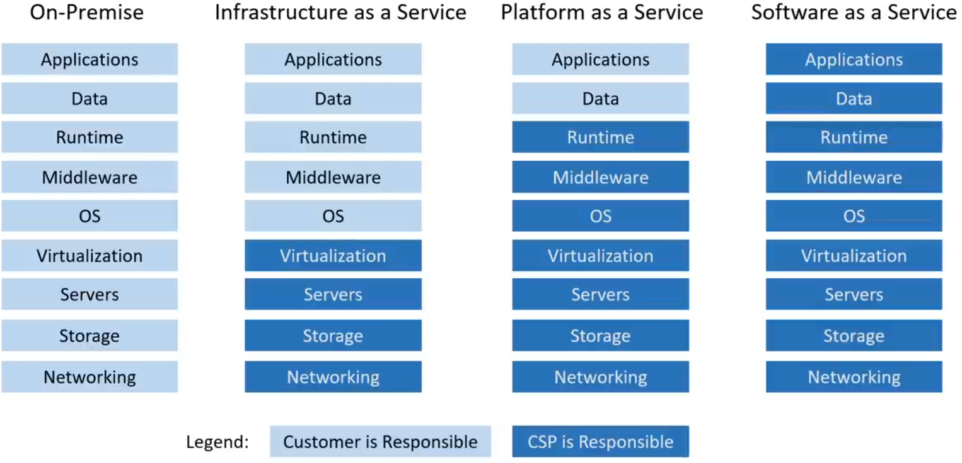

**AZURE DEPLOYMENT MODELS**

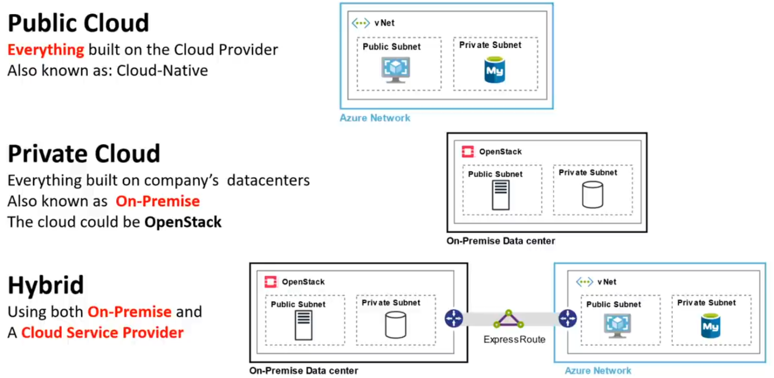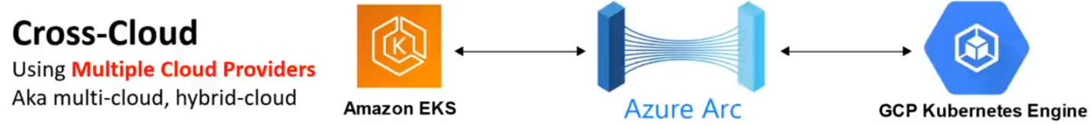

**PROs & CONs**

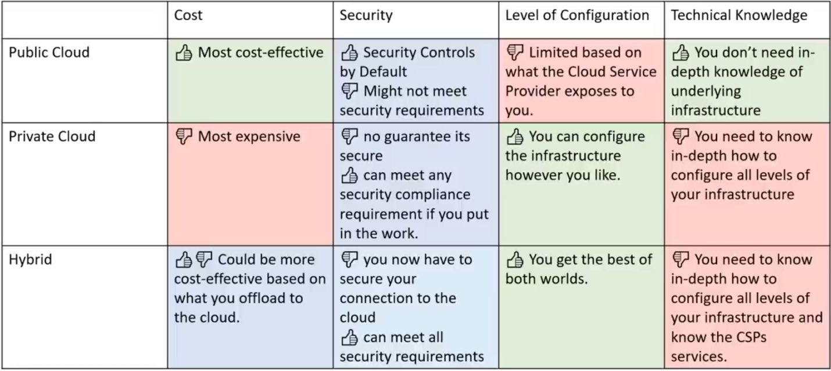

**TOTAL COST OF OWNERSHIP**

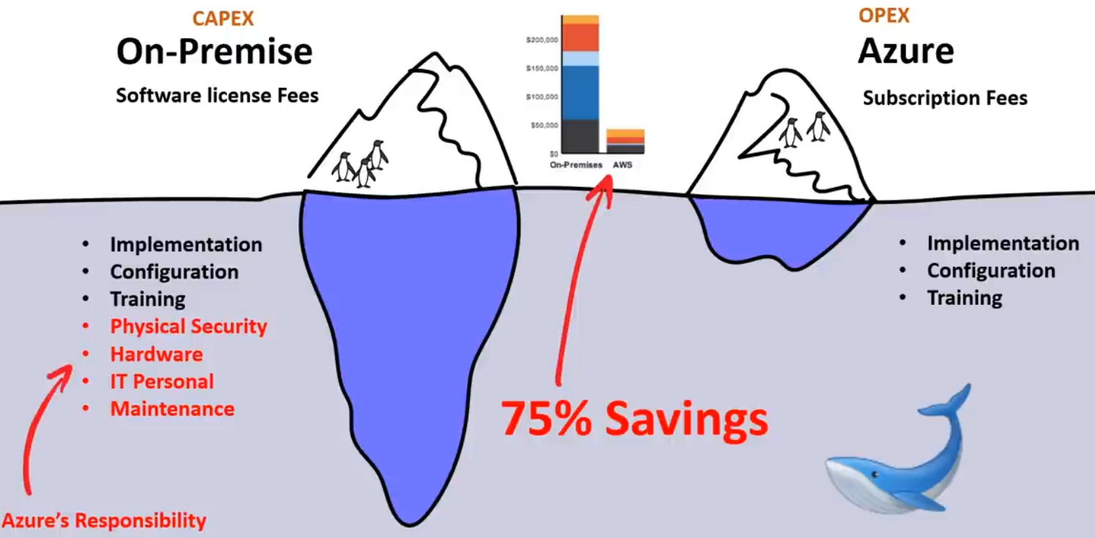

**CAPITAL V/S OPERATIONAL EXPENDITURE**

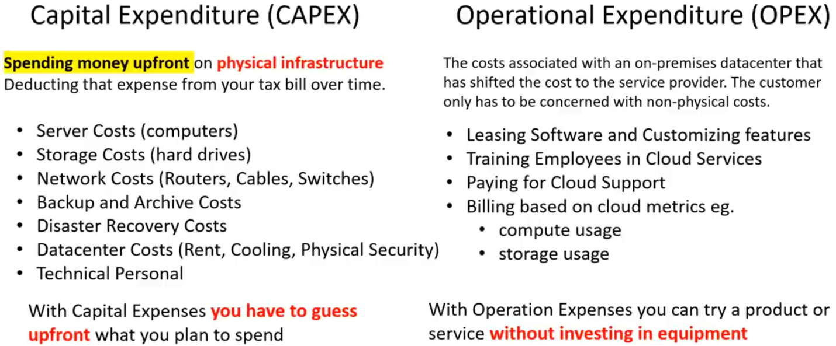

**CLOUD ARCHITECTURE TERMINOLOGIES**

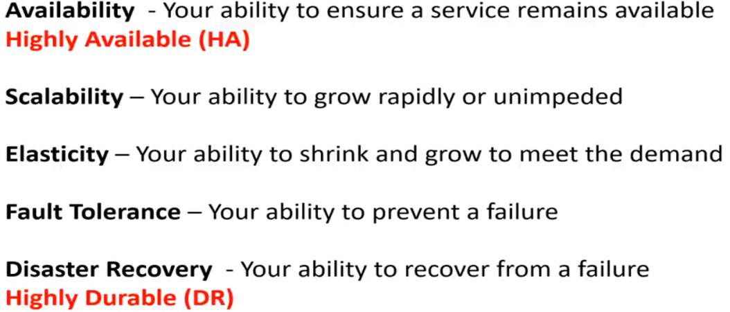

**HIGH AVAILABITY**

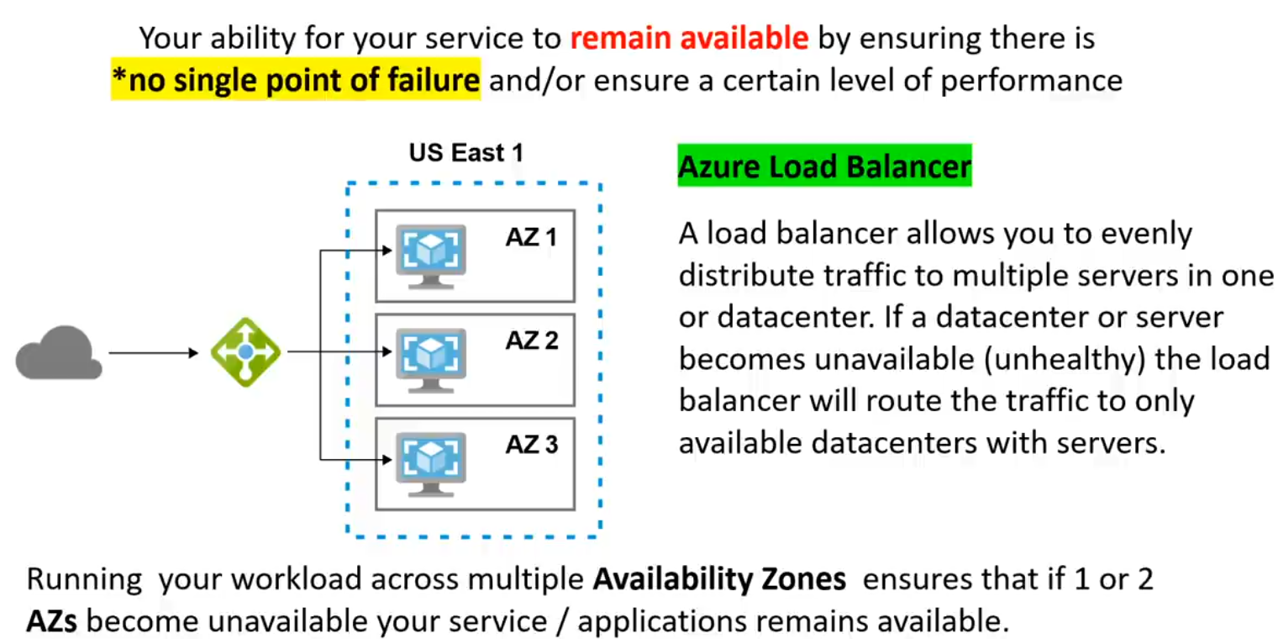

**HIGH SCALABILITY**

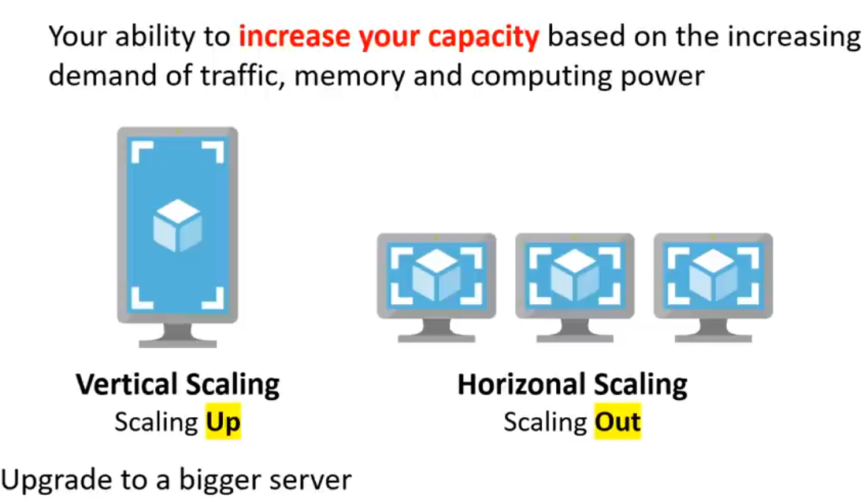

**HIGH ELASTICITY**

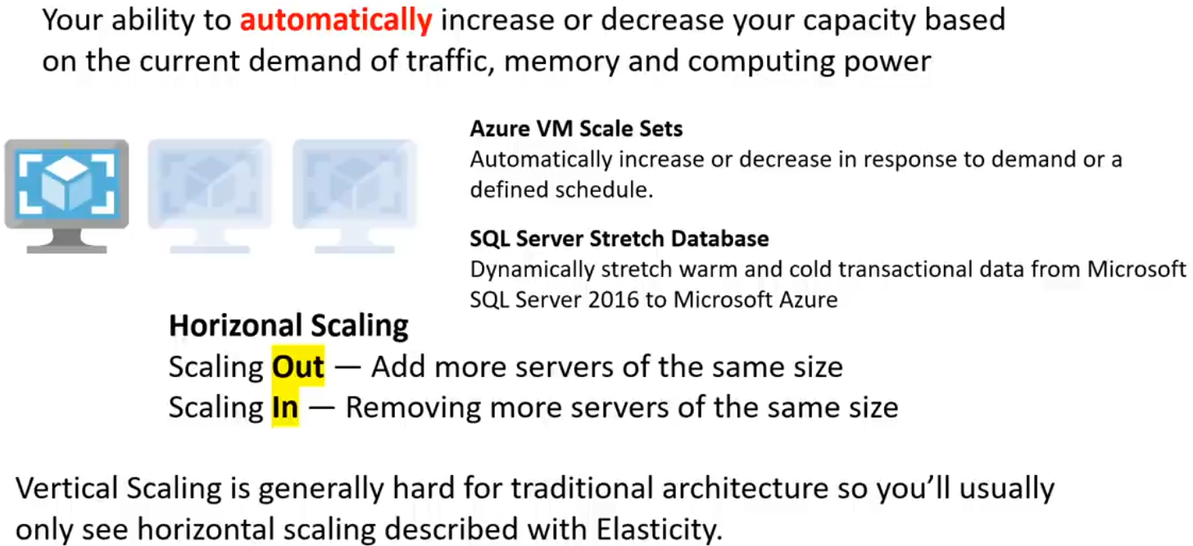

**HIGH DURABILITY**

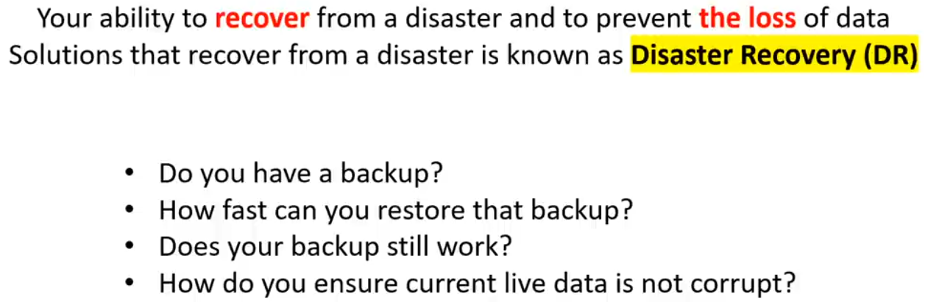

**EVOLUTION OF COMPUTING (DEDICATED SERVICES)**



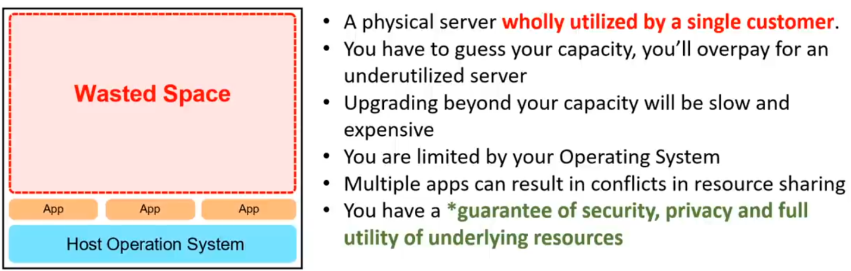

**EVOLUTION OF COMPUTING (Virtual machines)**

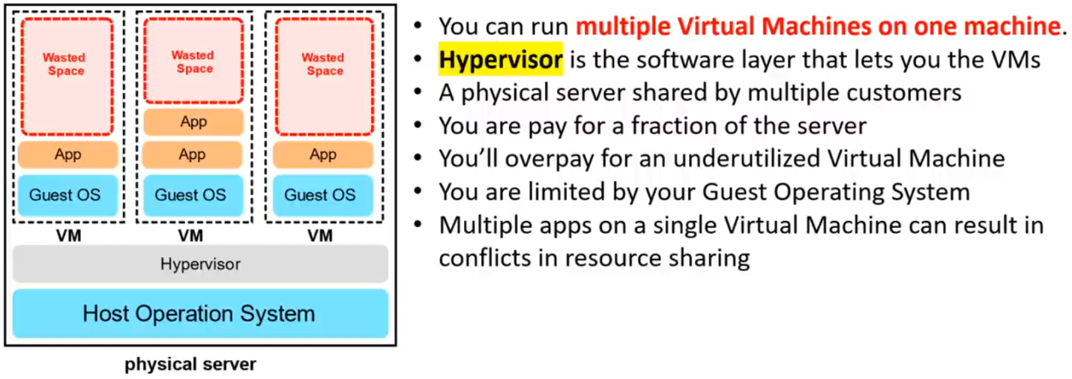

**EVOLUTION OF COMPUTING (Containers)**

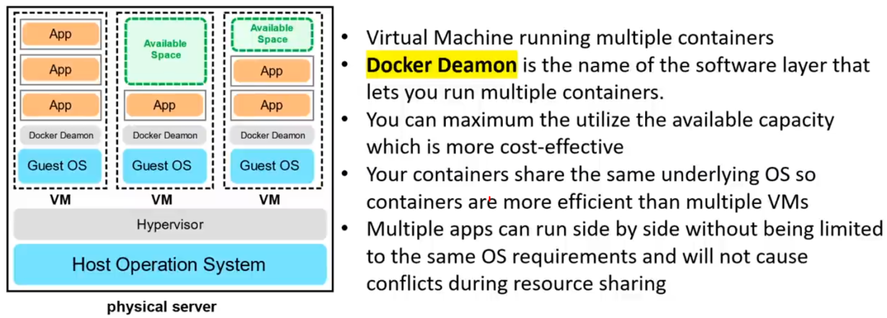

**EVOLUTION OF COMPUTING (Functions)**

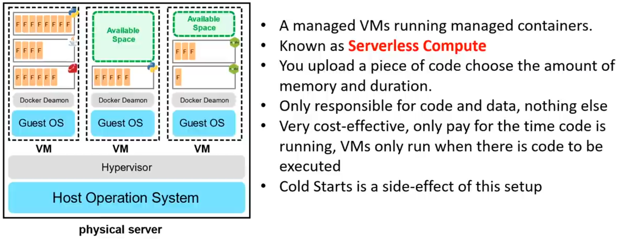

**REGIONS & GEOGRAPHIES**

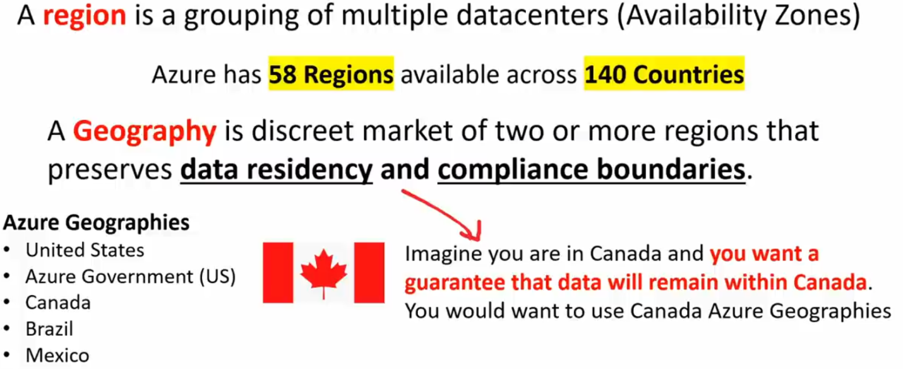

**PAIRED REGIONS**

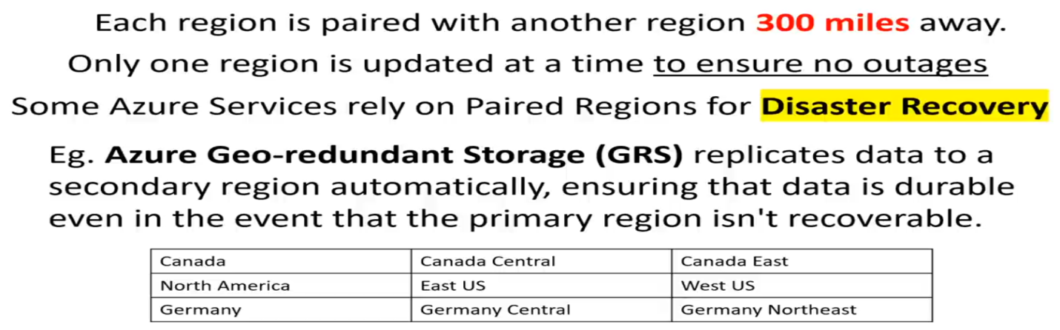

**REGION TYPES & SERVICE AVAILABILITY**

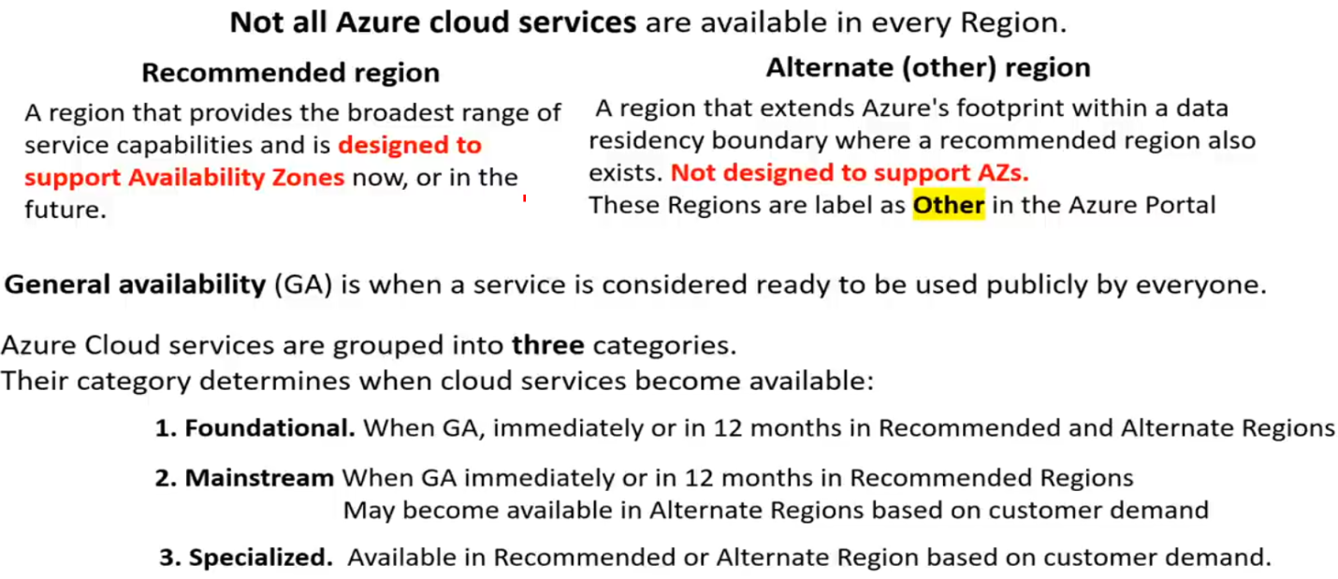

**SPECIAL REGIONS**

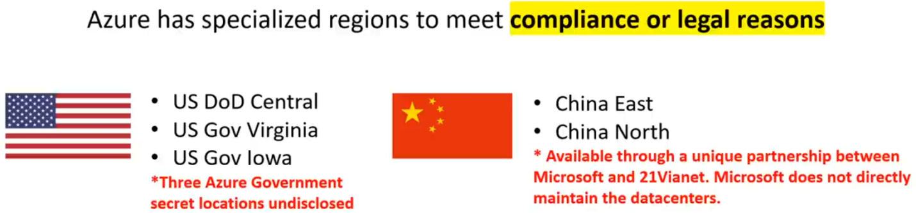

**AVAILABILITY ZONE**

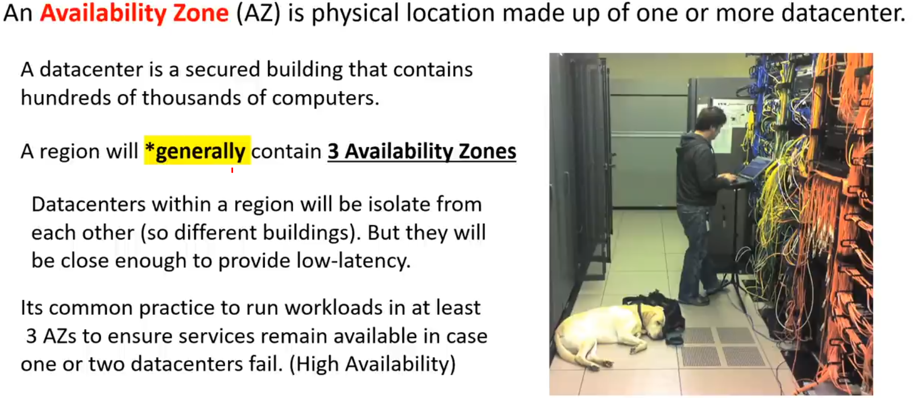

**AZ SUPPORTED REGIONS**

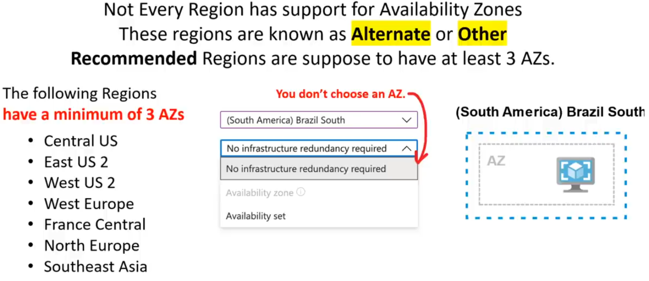

**FAULT & UPDATE DOMAINS**

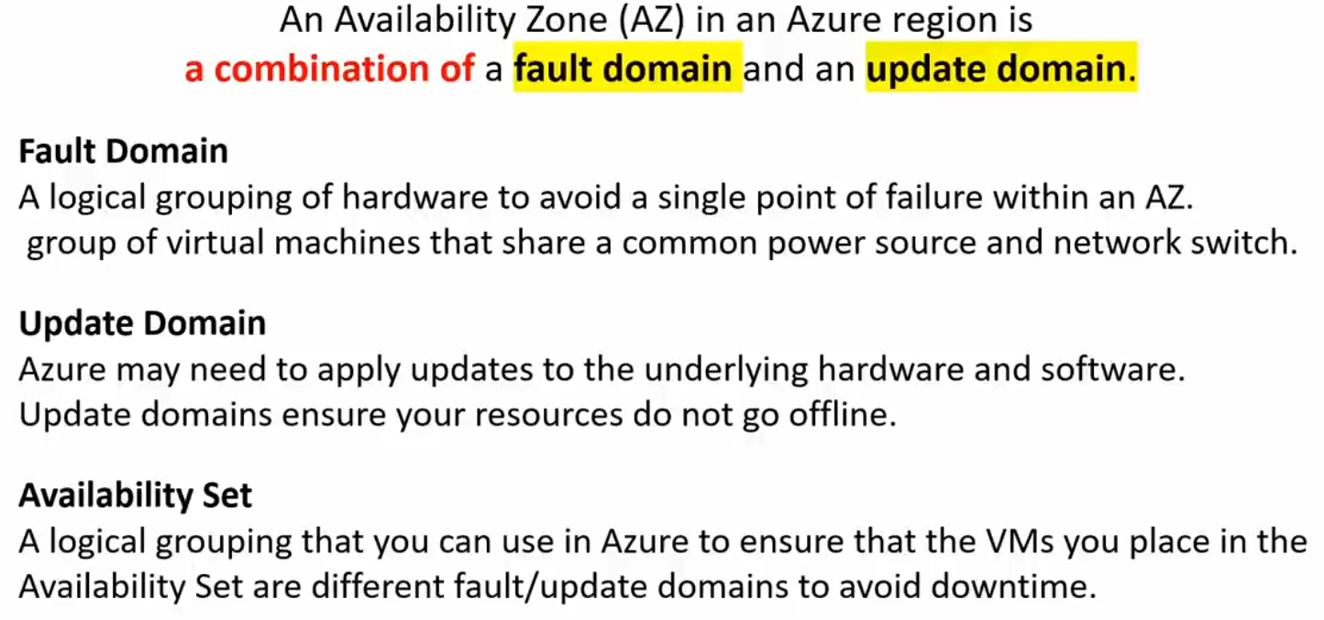

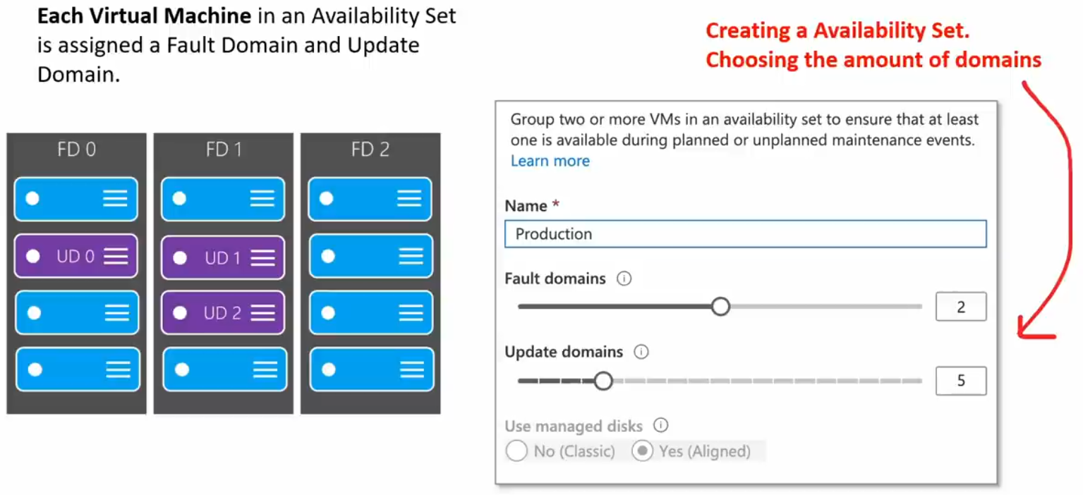

**AZURE COMPUTING SERVICES**

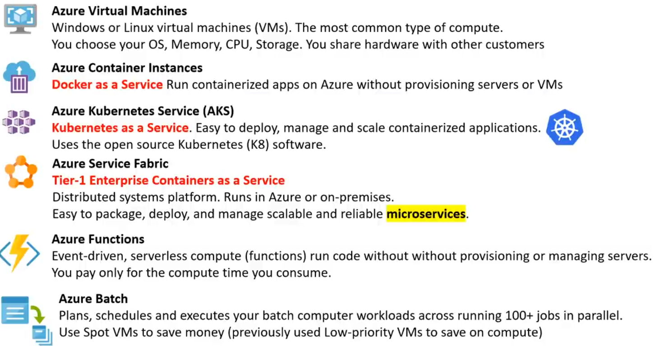

**STORAGE SERVICES**

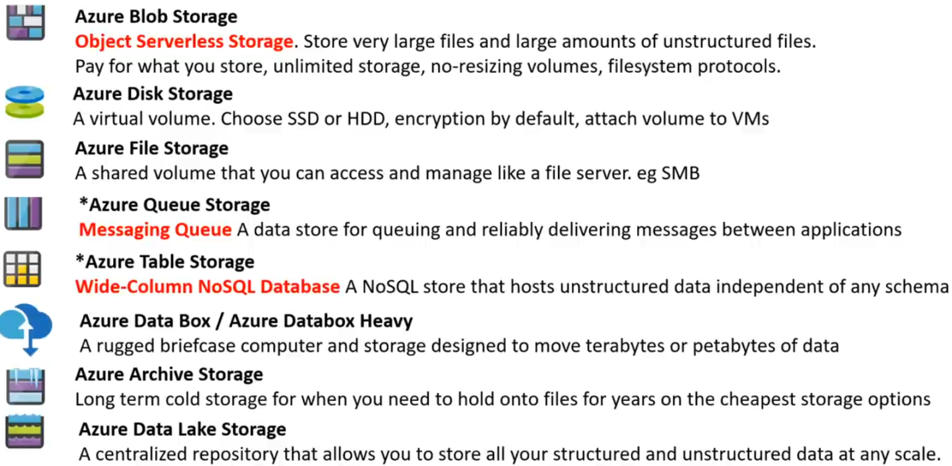

**DATABASE SERVICES**

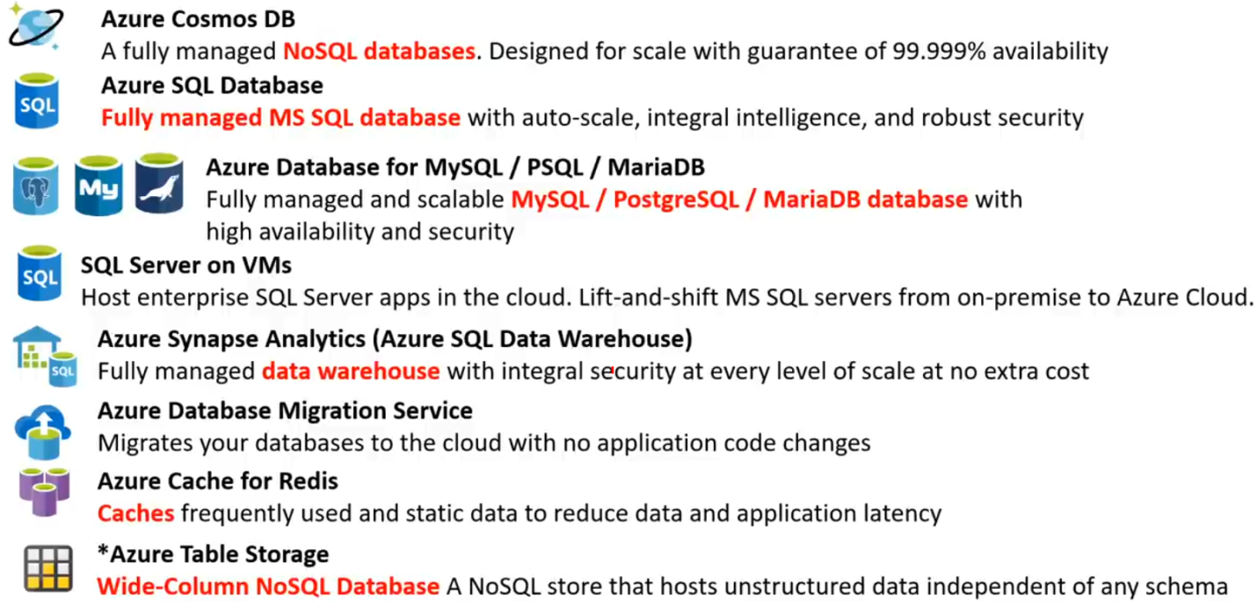

**APPLICATION INTEGRATION SERVICES**

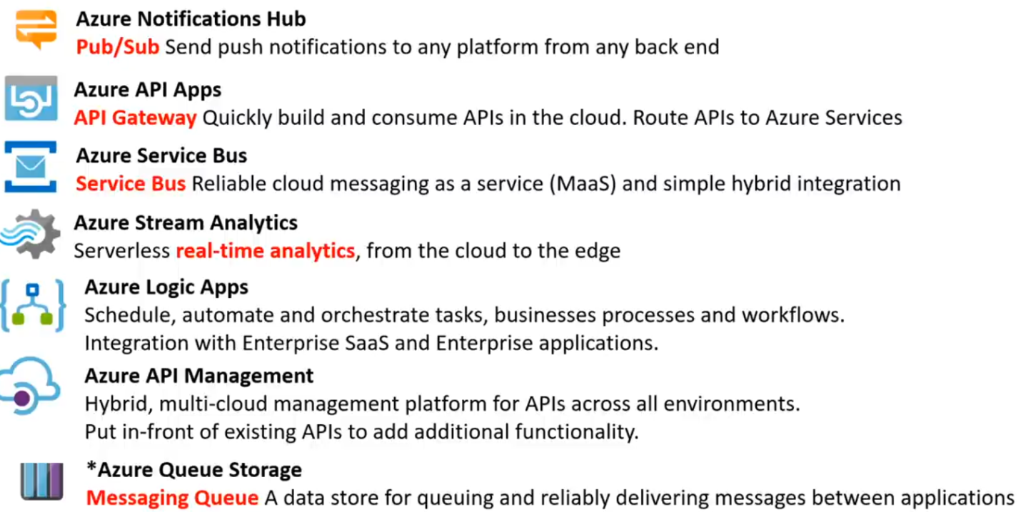

**DEVELOPER MOBILE TOOLS**

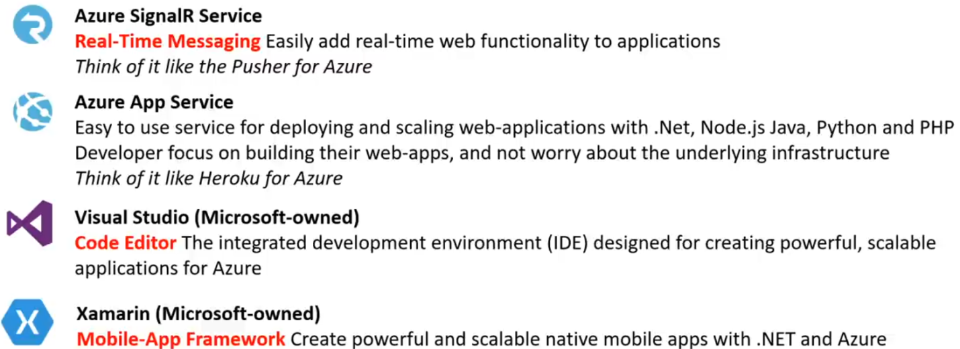

**AZURE DevOps SERVICE**

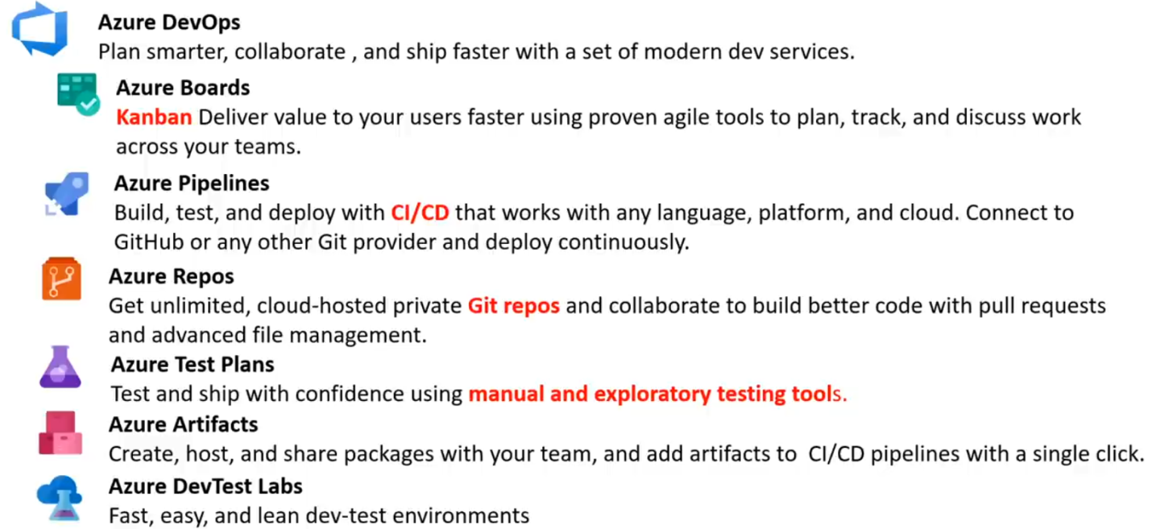

**AZURE RESOURCE MANAGER(ARM)**

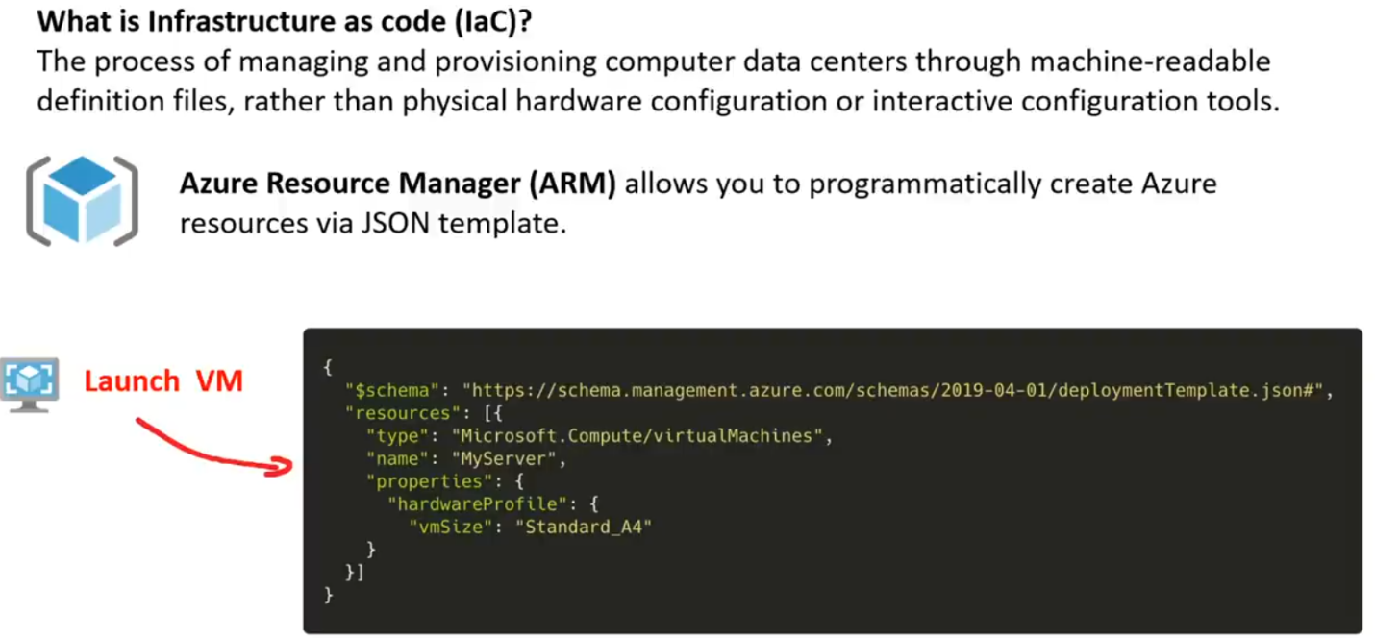

**AZURE QUICK START TEMPLATES**

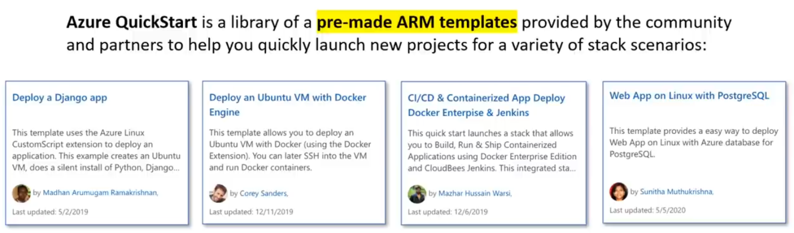

**VIRTUAL NETS (vNETs) & SUB NETS**

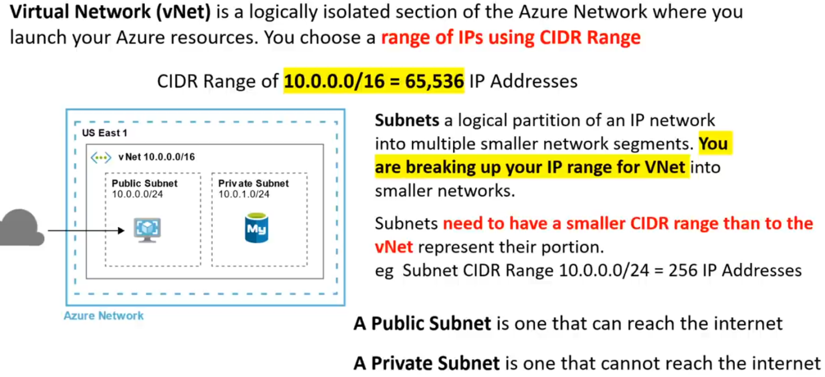

**CLOUD NATIVE NETWORKING SERVICE**

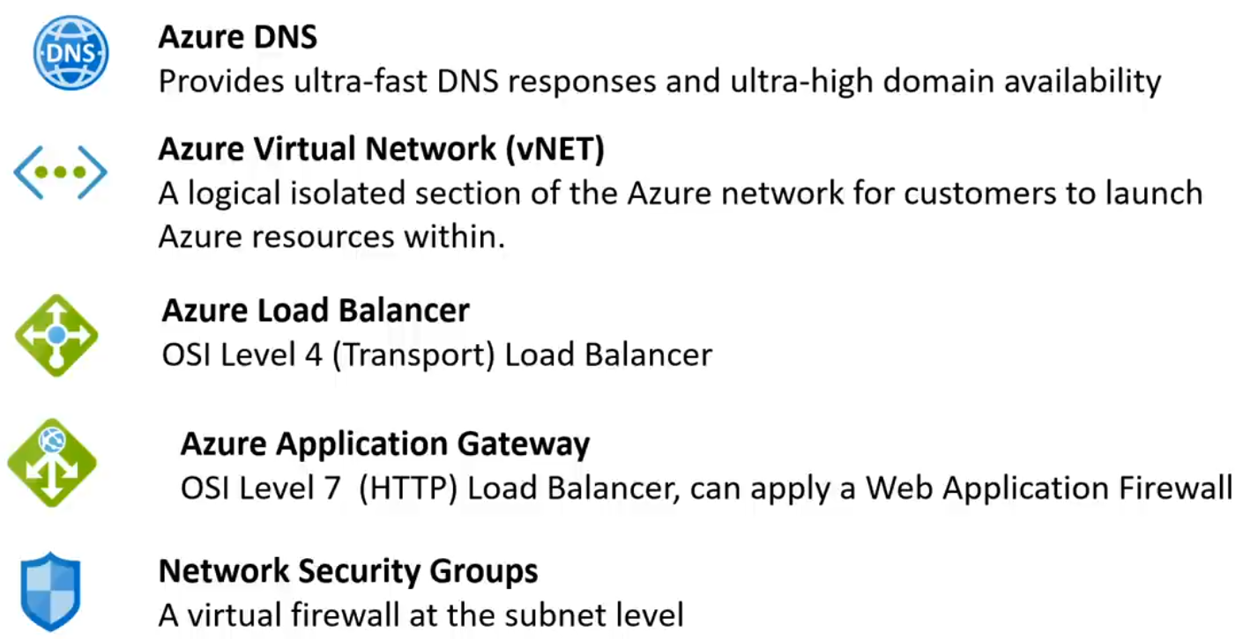

**ENTERPRISE/HYBRID NETWORKING SERVICES**

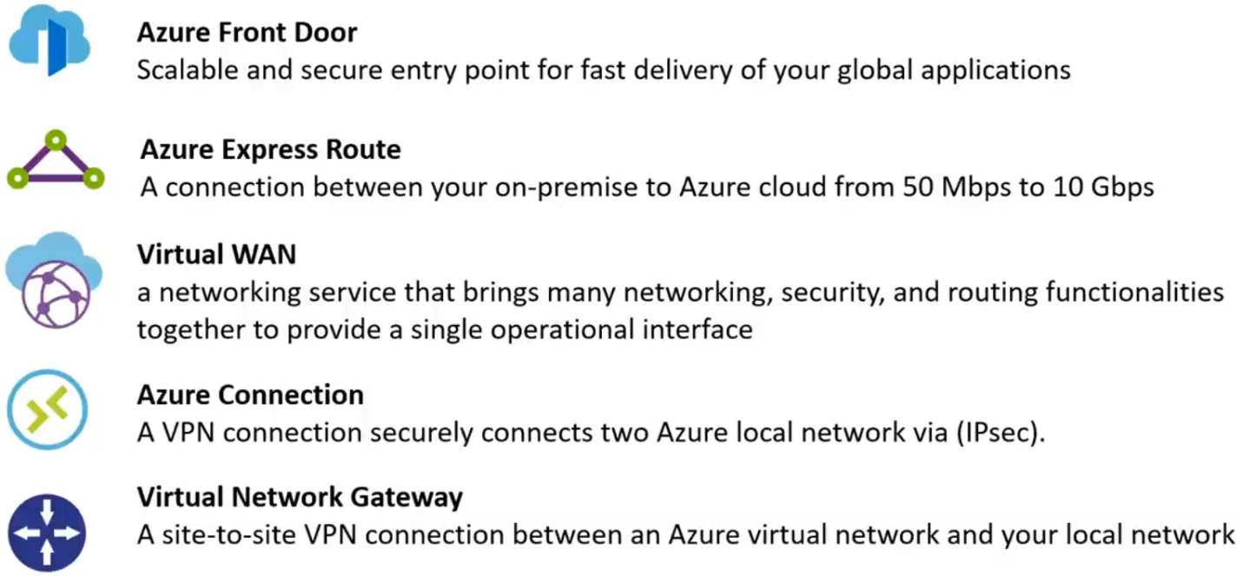

**AZURE TRAFFIC MANAGER**

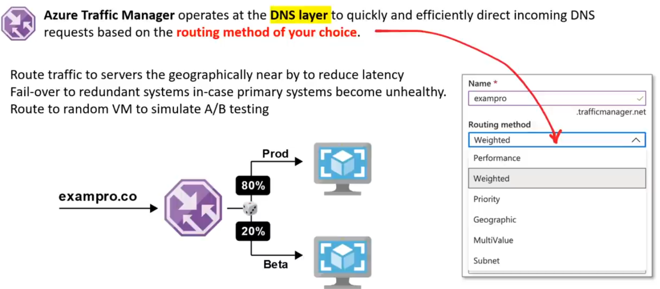

**AZURE DNS**

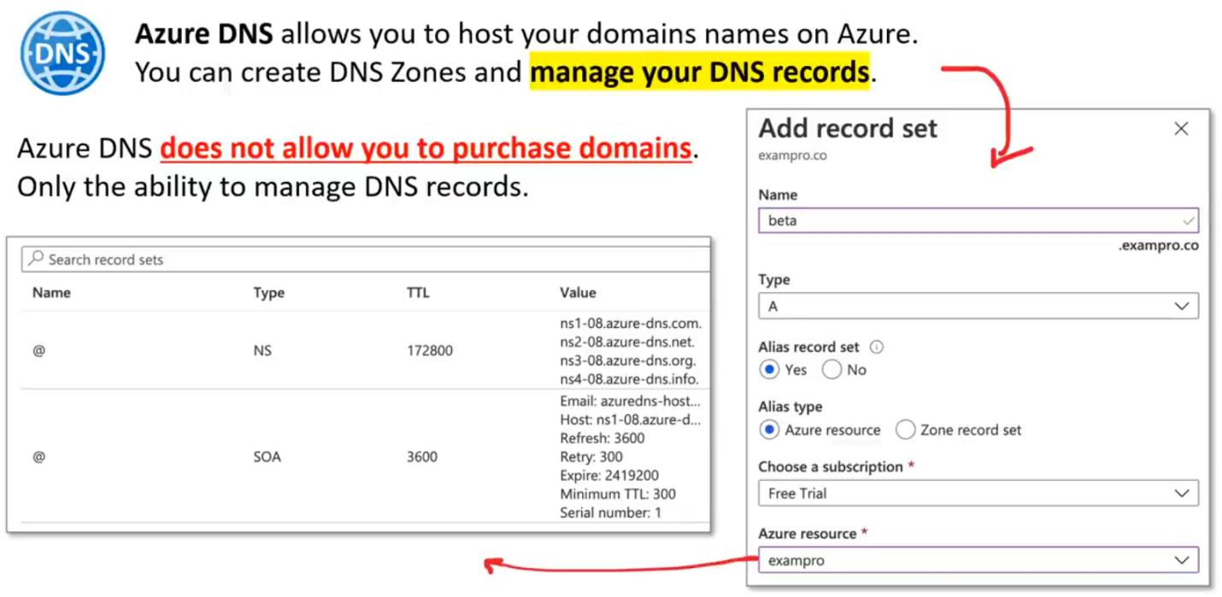

**AZURE LOAD BALANCER**

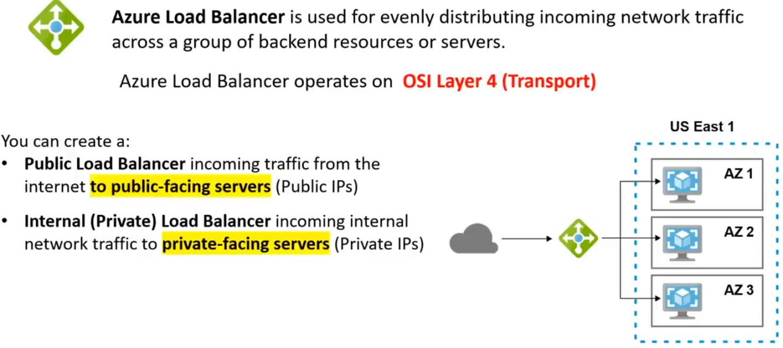

**SCALE SETS**

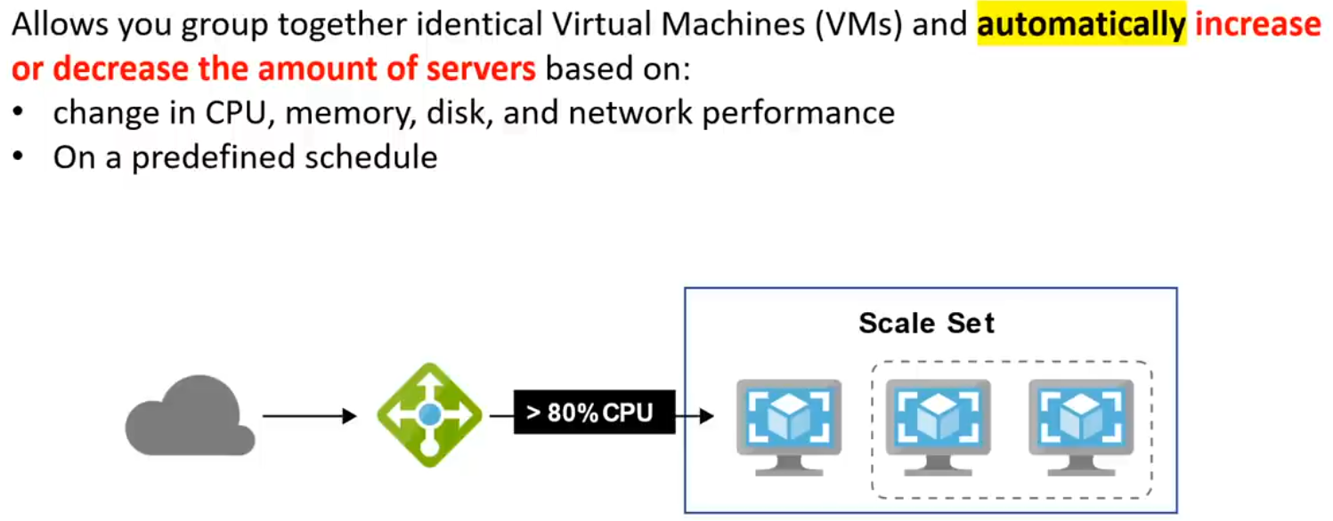

**IOT SERVICES**

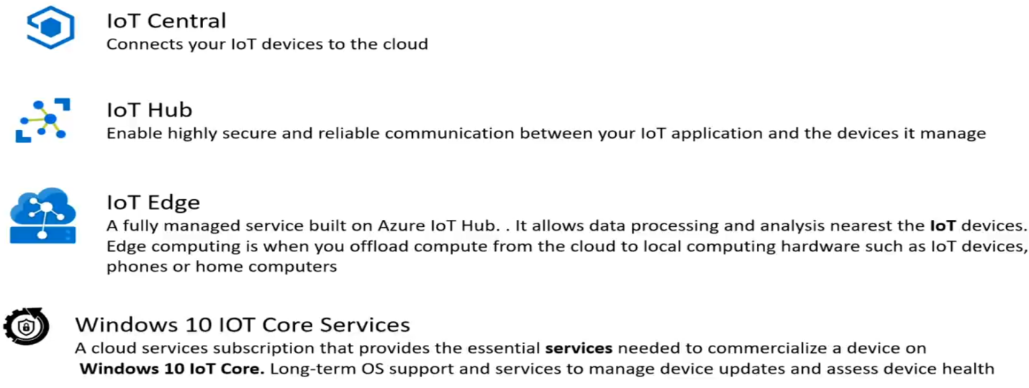

**BIG DATA AND ANALYTICS SERVICES**

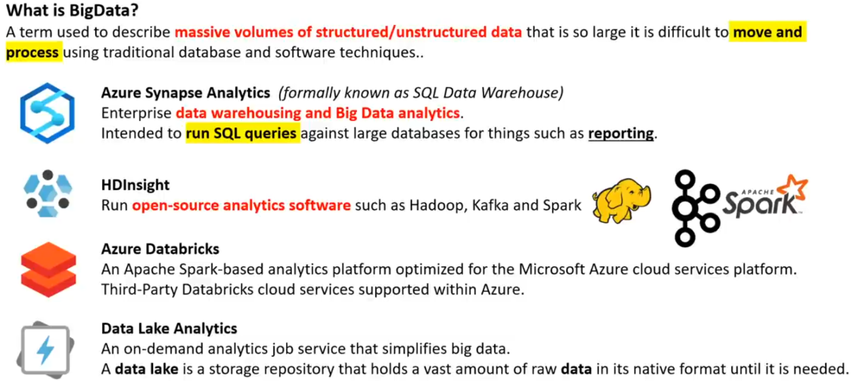

**AI/ML SERVICES**

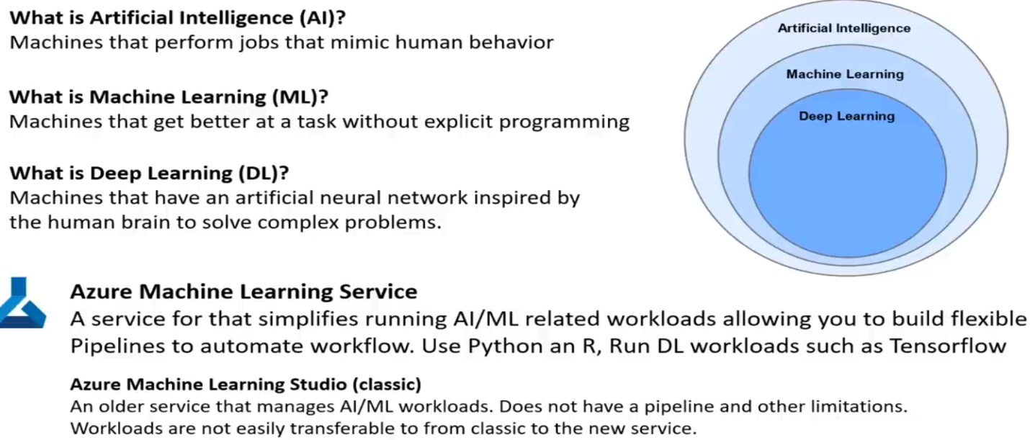

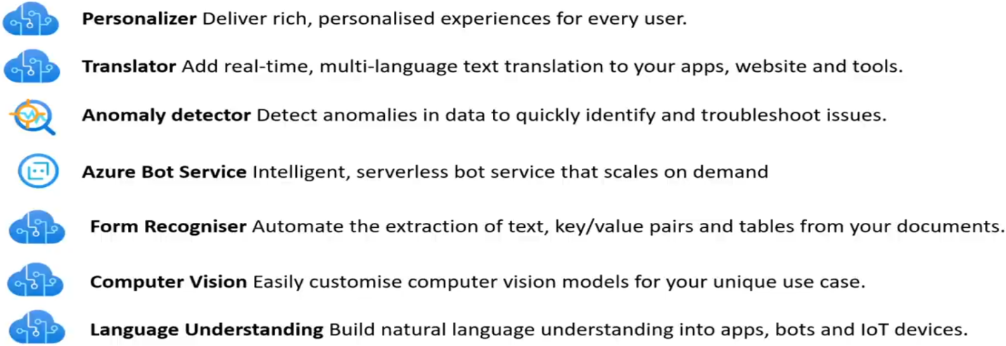

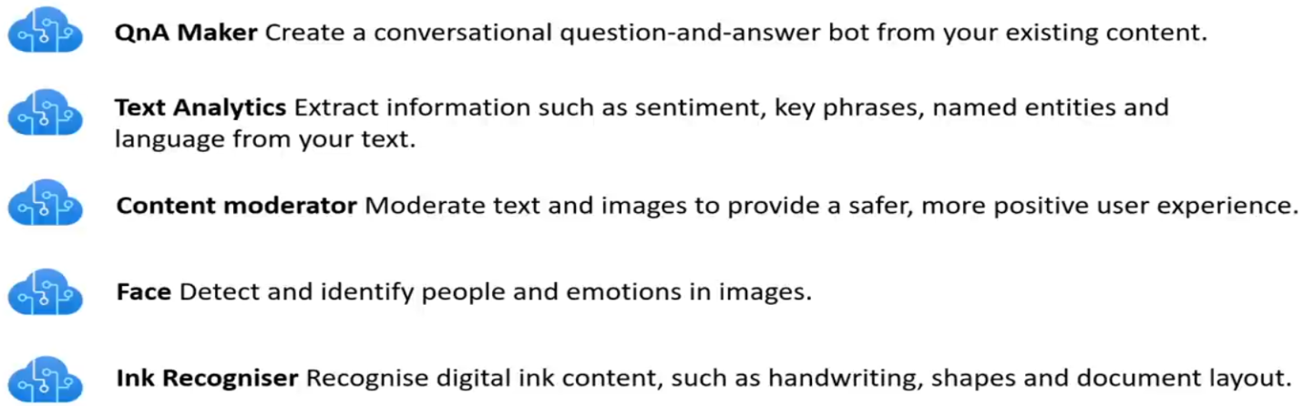

**SERVERLESS SERVICE**

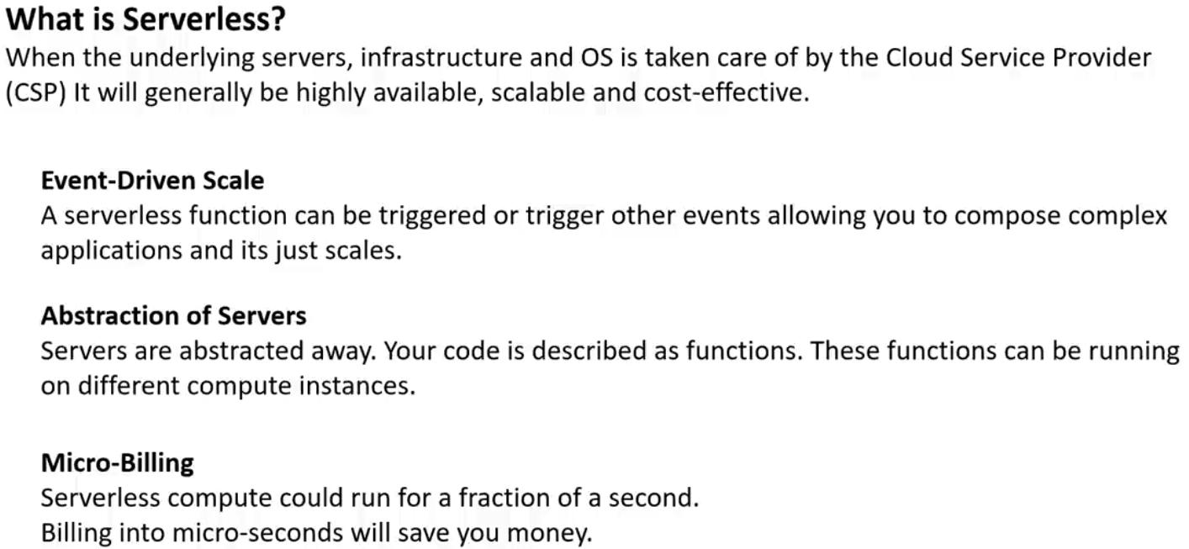

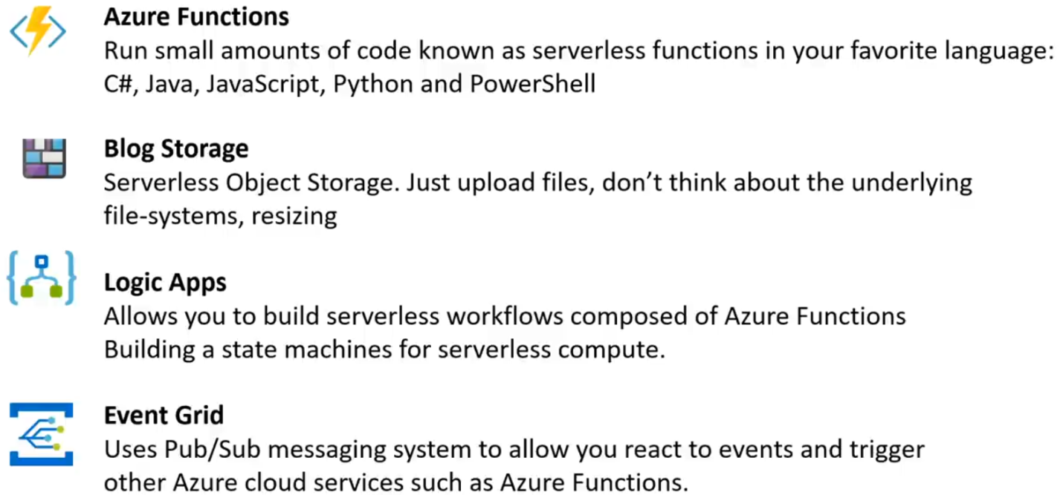

**AZURE PORTAL**

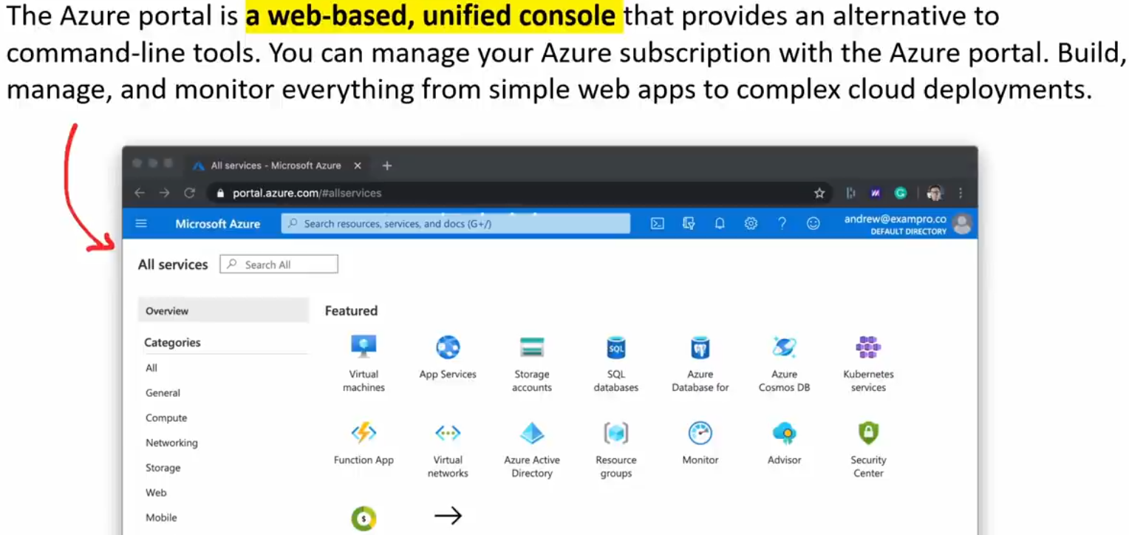

**AZURE PREVIEW PORTAL**

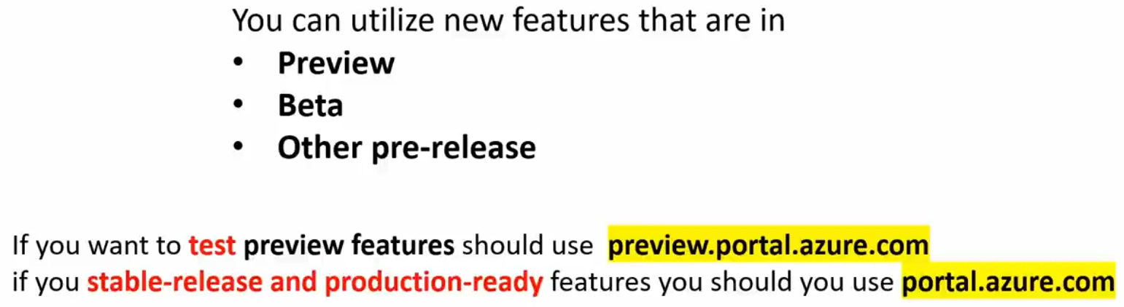

**AZURE POWERSHELL**

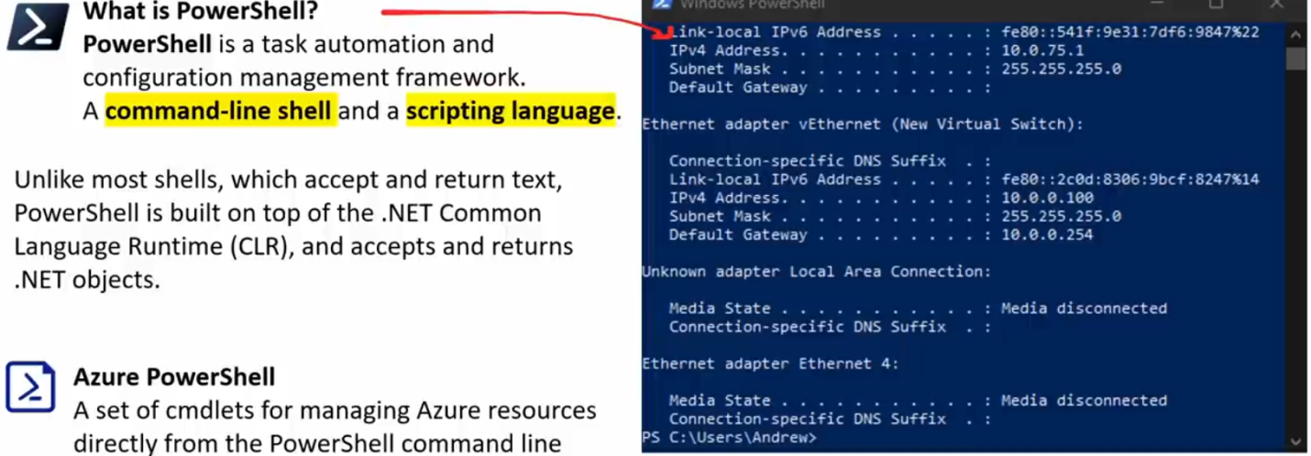

**AZURE CLOUD SHELL**

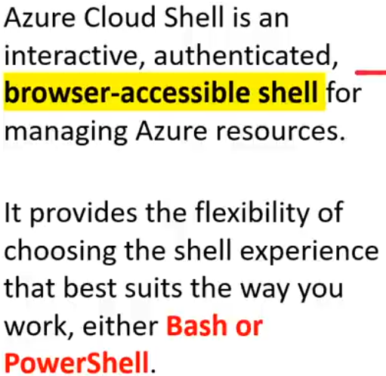

**AZURE CLI**

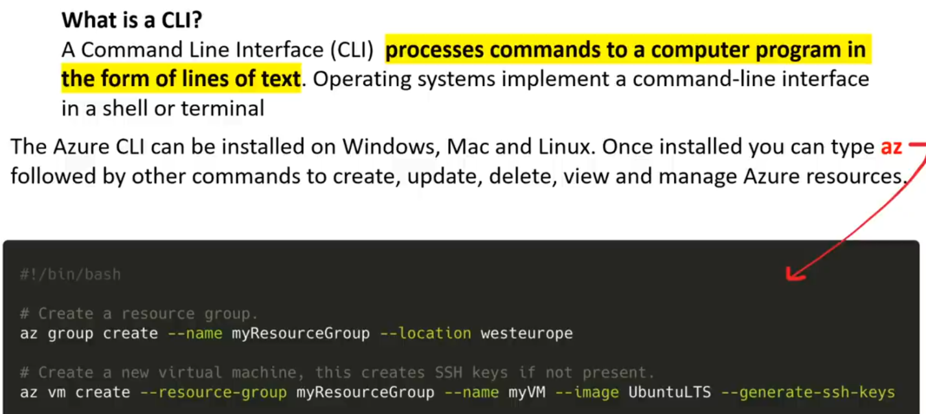

**Azure COMPLIANCE PROGRAM**

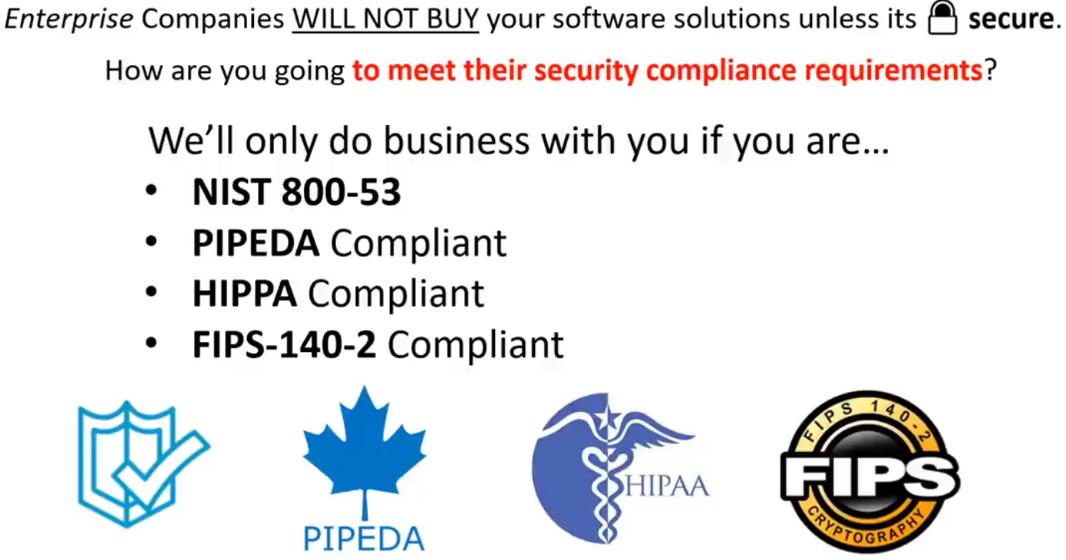

**AZURE ACTIVE DIRECTORY**

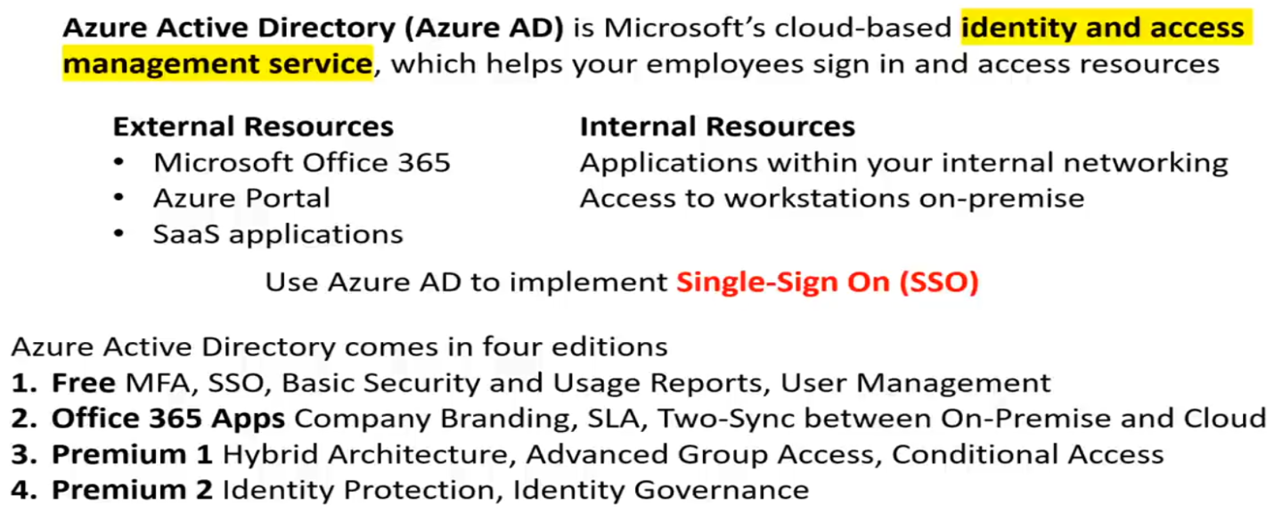

**MULTI FACTOR AUTHENTICATION**

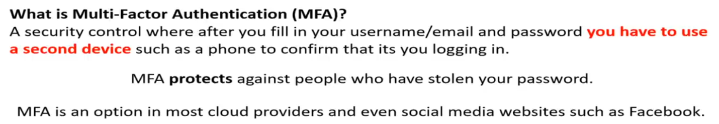

**AZURE SECURITY CENTER**

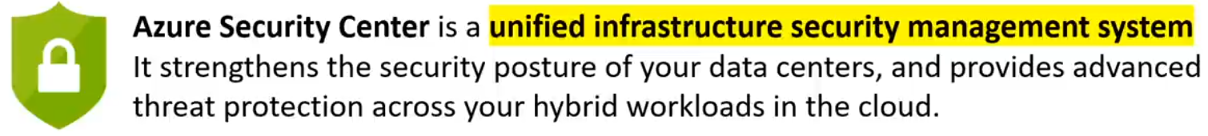

**KEY VAULT**

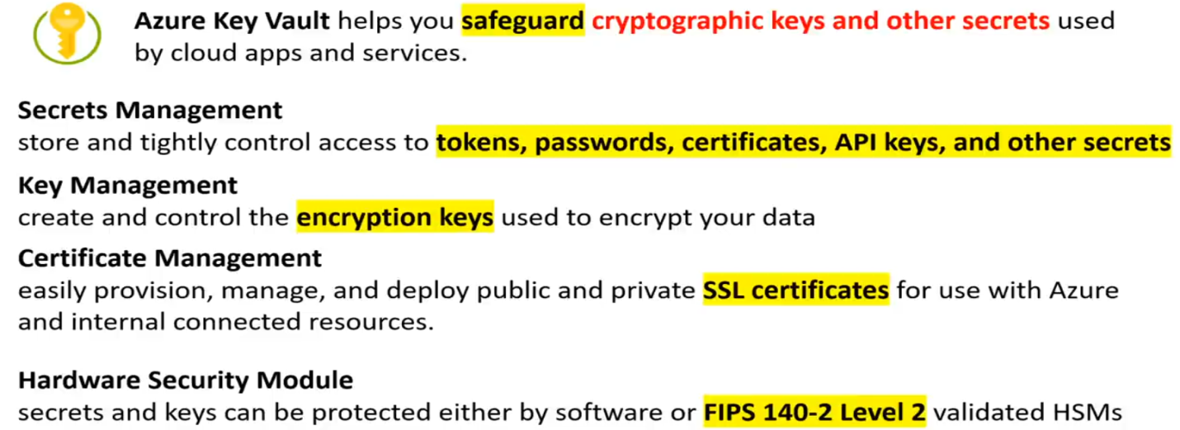

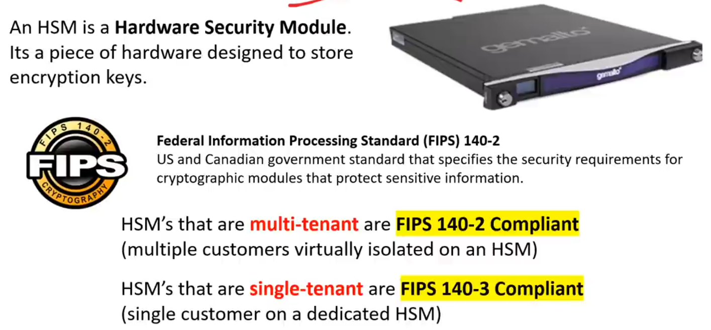

**AZURE DDOS PROTECTION**

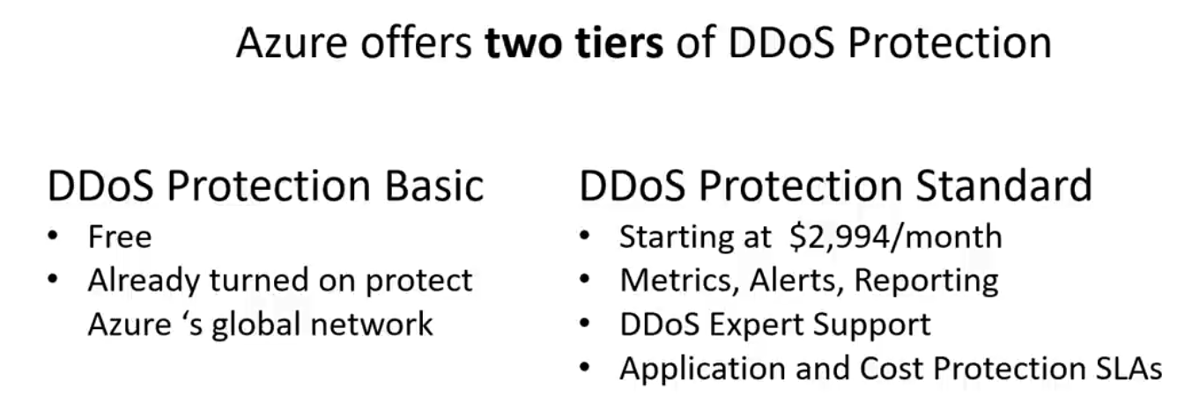

**AZURE FIREWALL**

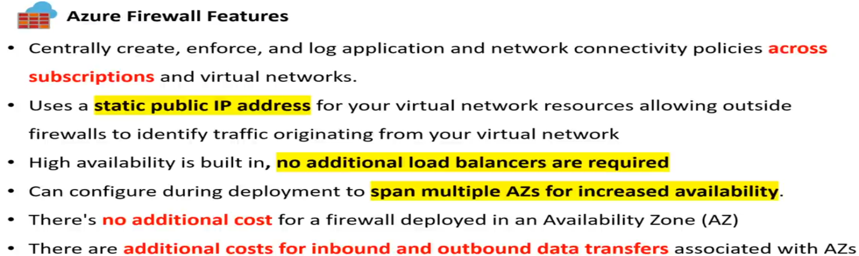

**AZURE INFORMATION PROTECTION**

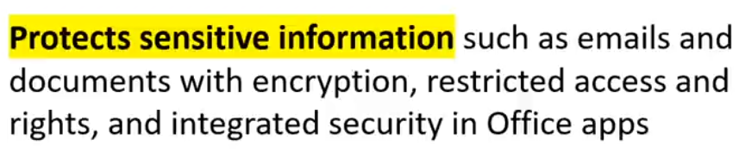

**APPLICATION GATEWAY**

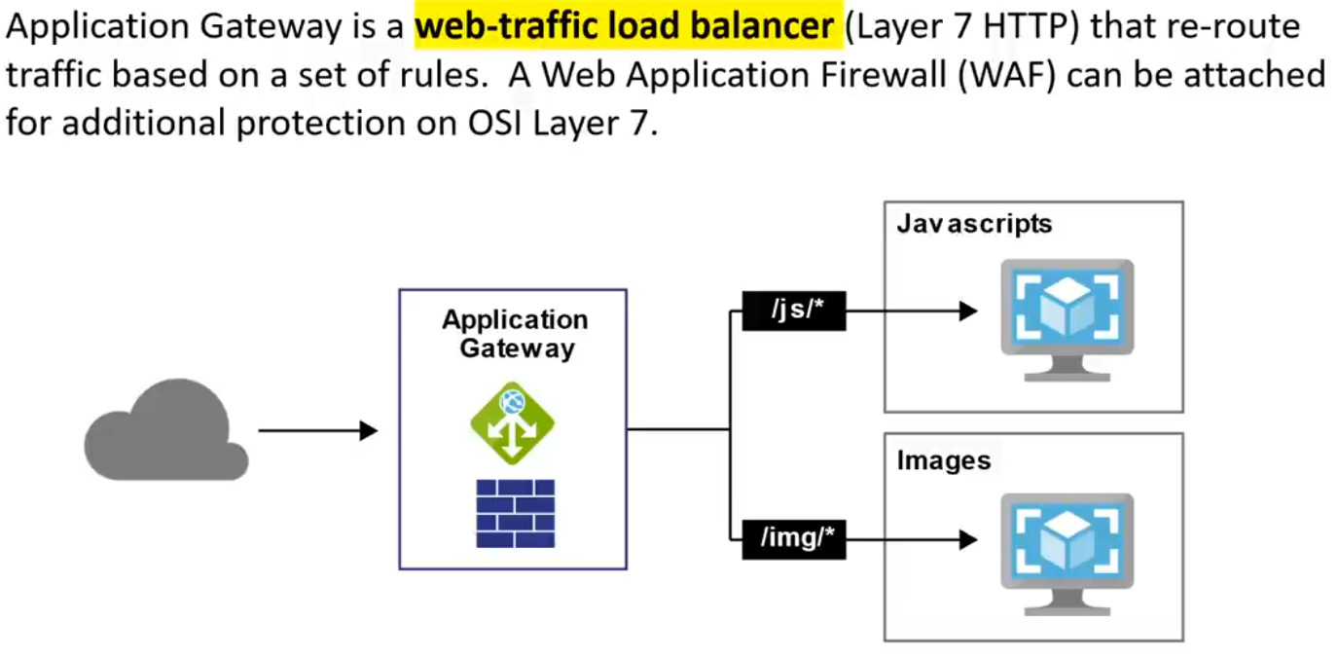

**ADVANCED THREAT PROTECTION**

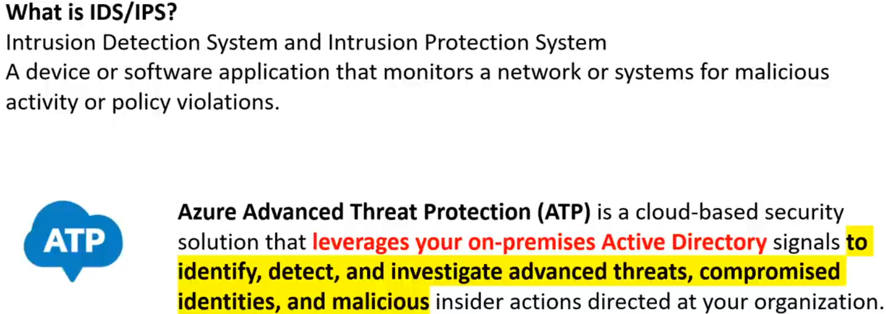

**SECURITY DEVELOPMENT LIFECYCLE**

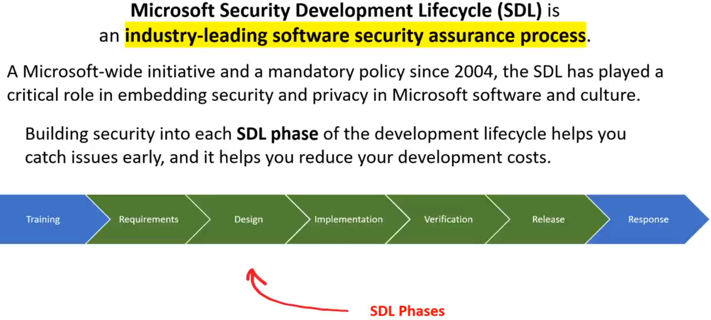

**AZURE POLICIES**

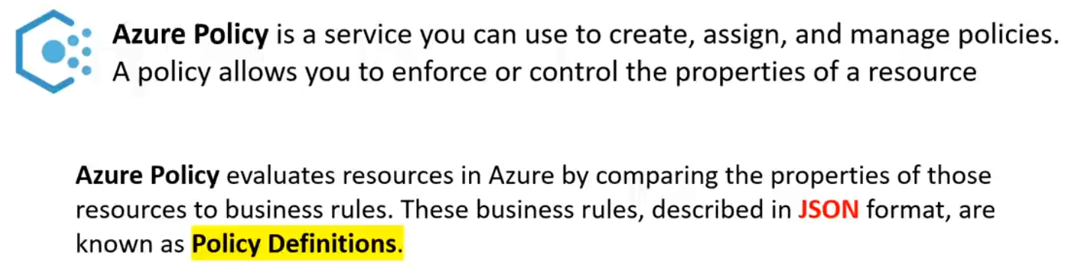

**ROLE BASED ACCESS CONTROL**

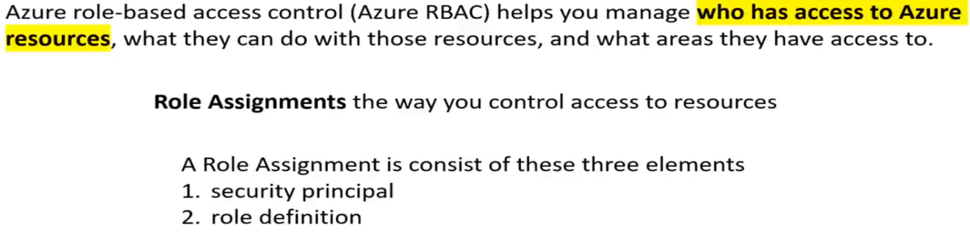

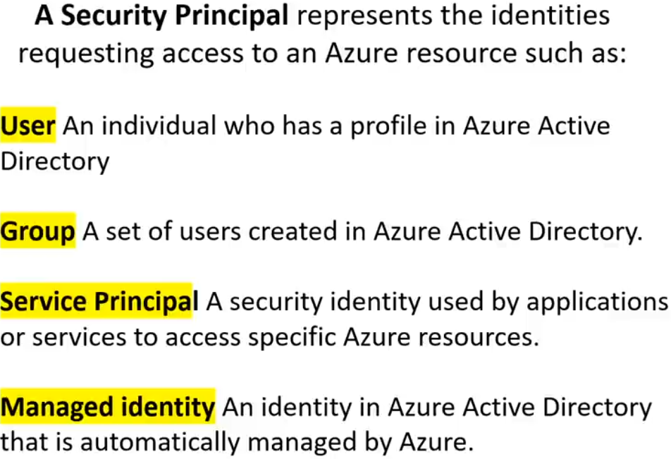

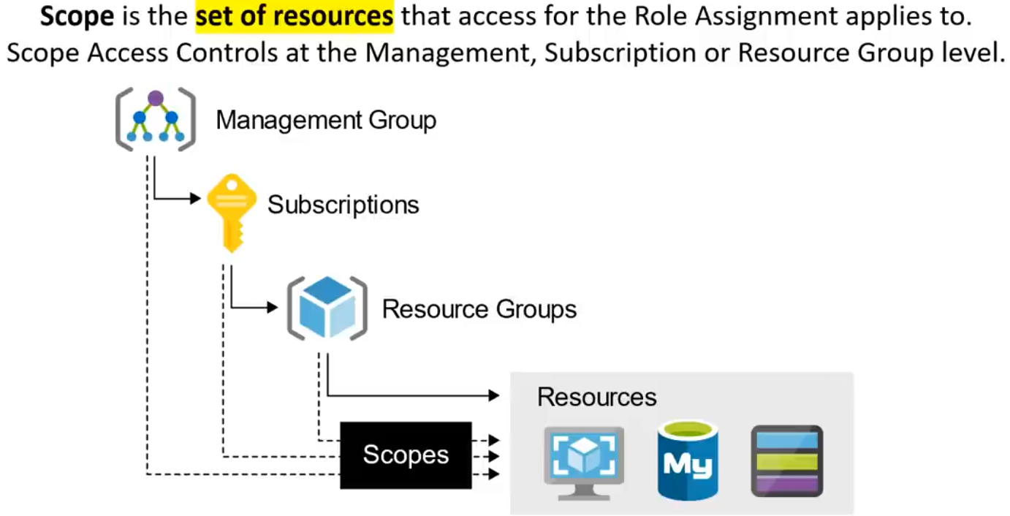

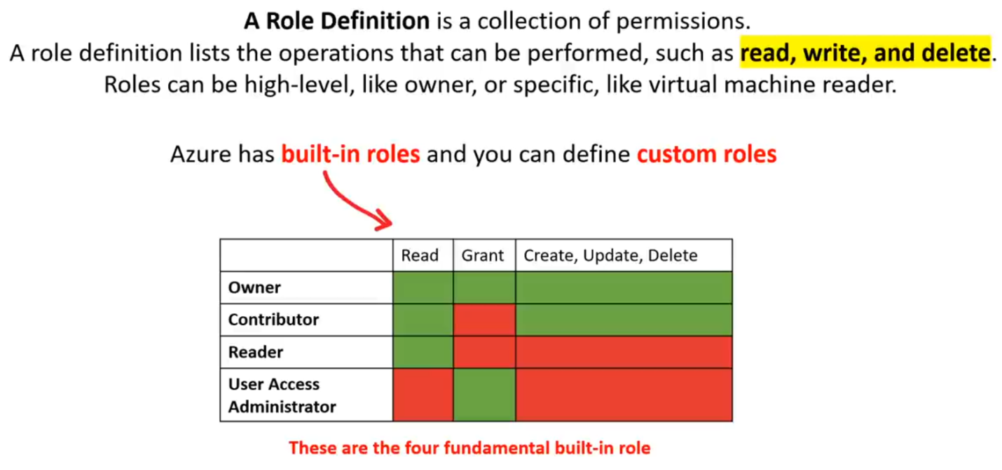

**LOCK RESOURCES**

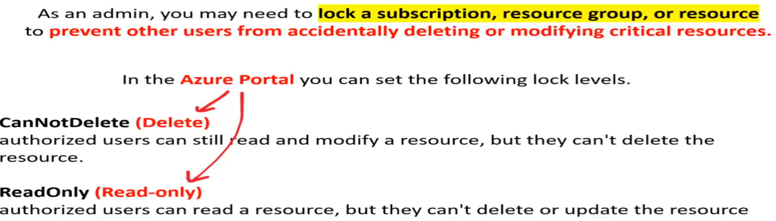

**AZURE MANAGEMENT GROUPS**

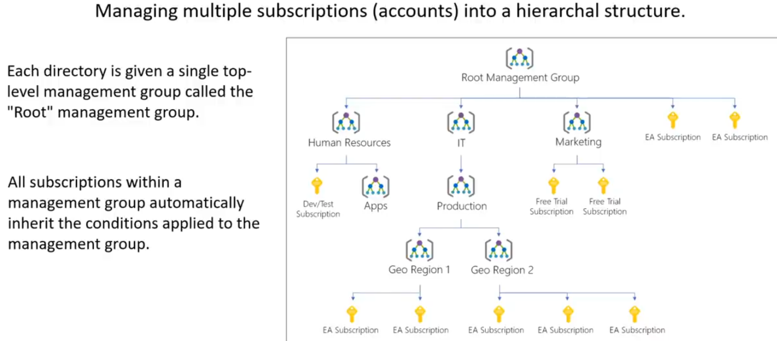

**AZURE MONITOR**

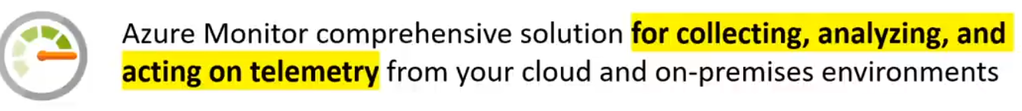

**AZURE SERVICE HEALTH**

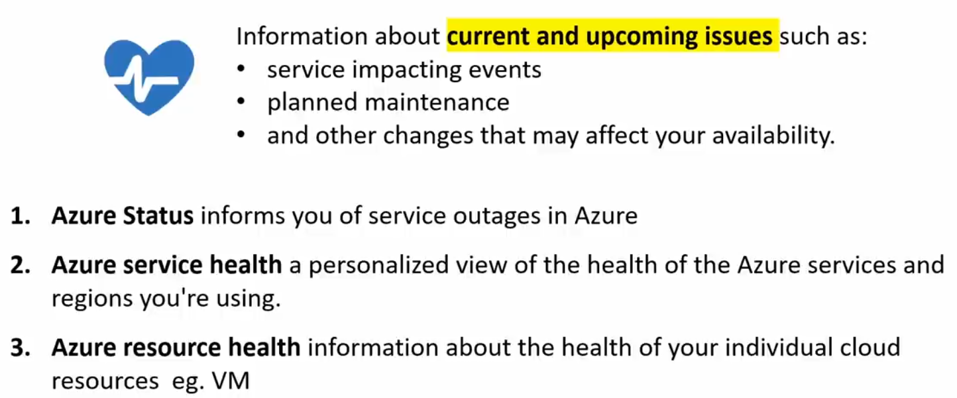

**AZURE ADVISOR**

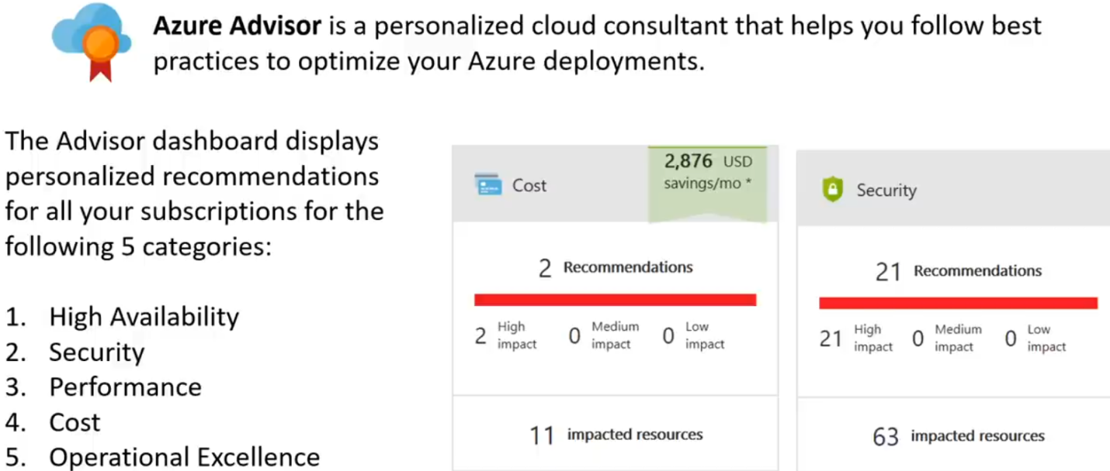

**SERVICE LEVEL AGREEMENT(SLA)**

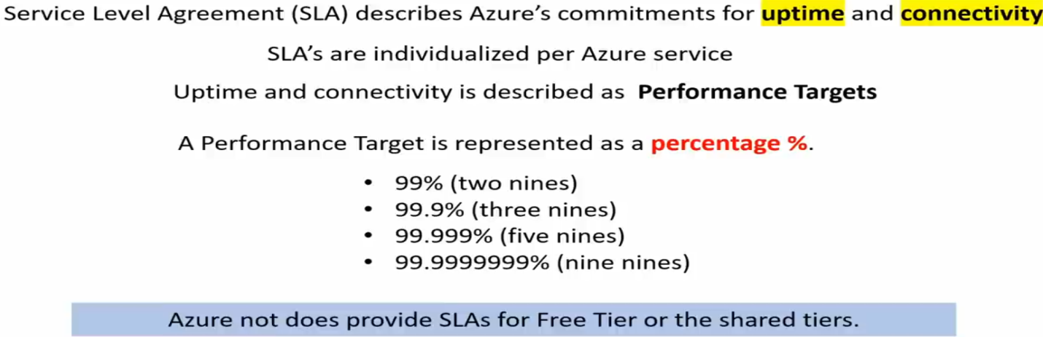

**SERVICE CREDITS**

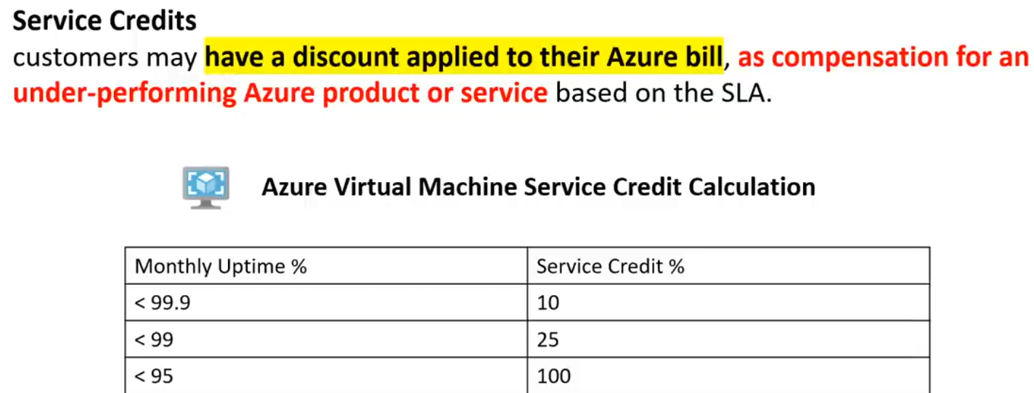

**COMPOSITE SLA**

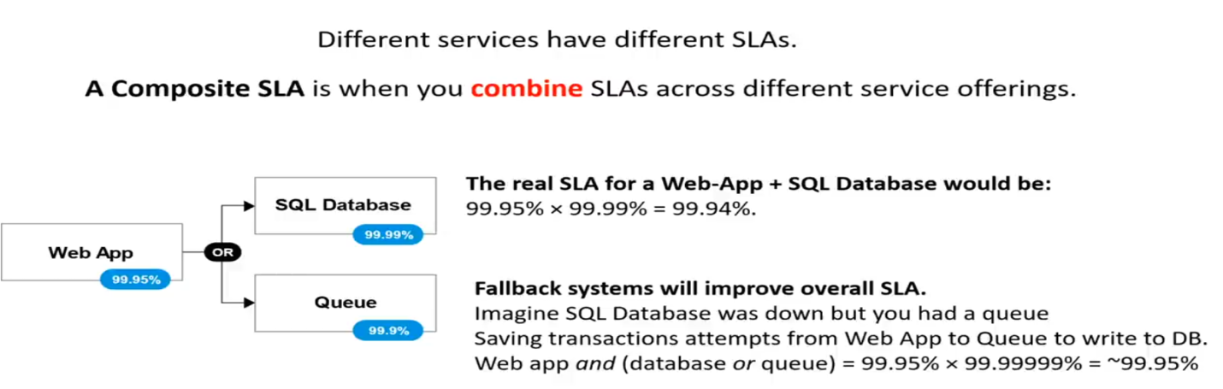

**AZURE MARKET PLACE**



**AZURE SUPPORT PLANS**

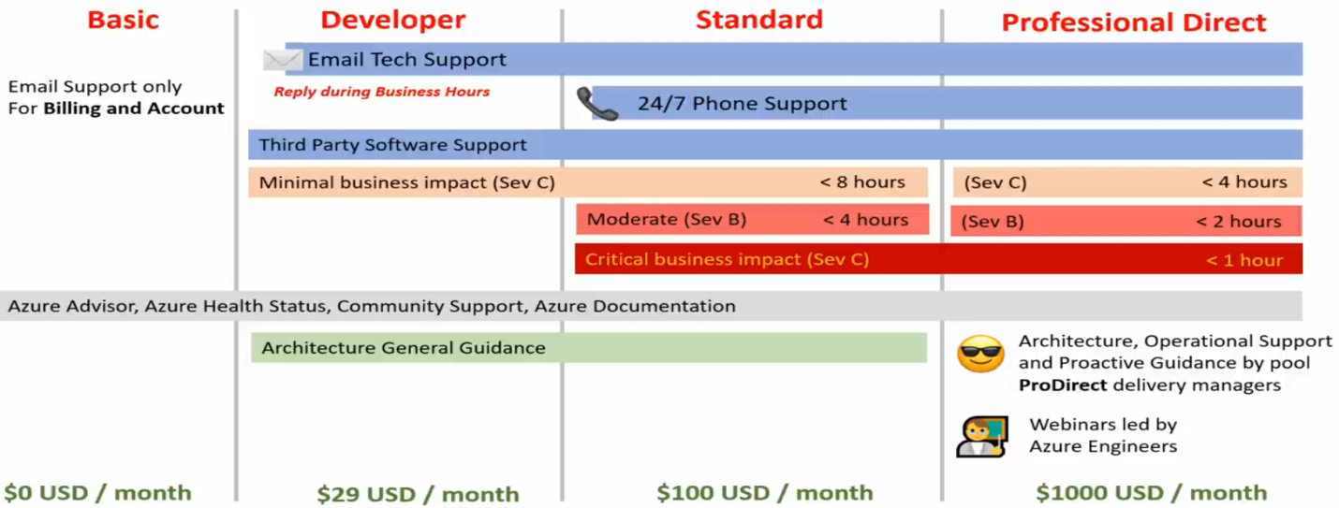

**AZURE LICENSING**

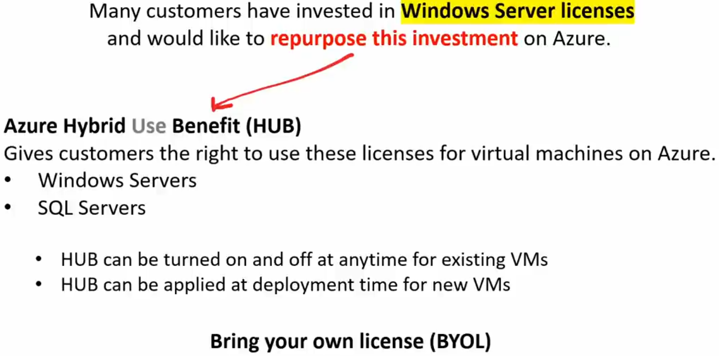

**AZURE SUBSCRIPTIONS**

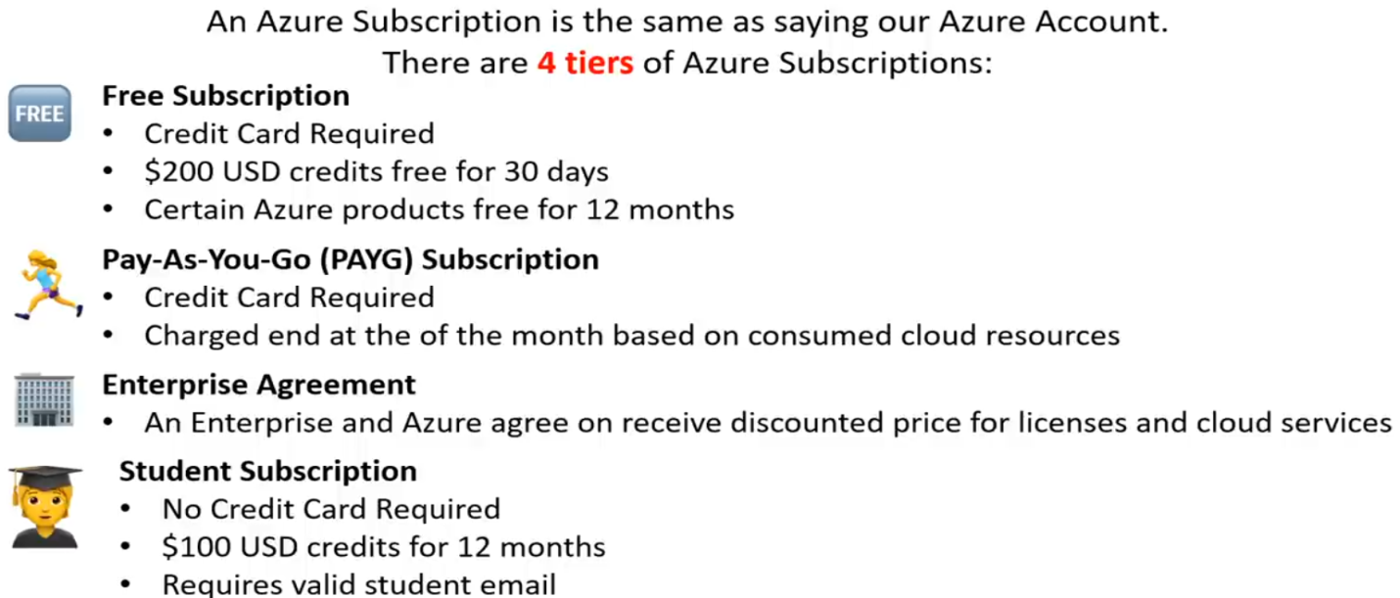

**AZURE COST MANAGEMENT**

